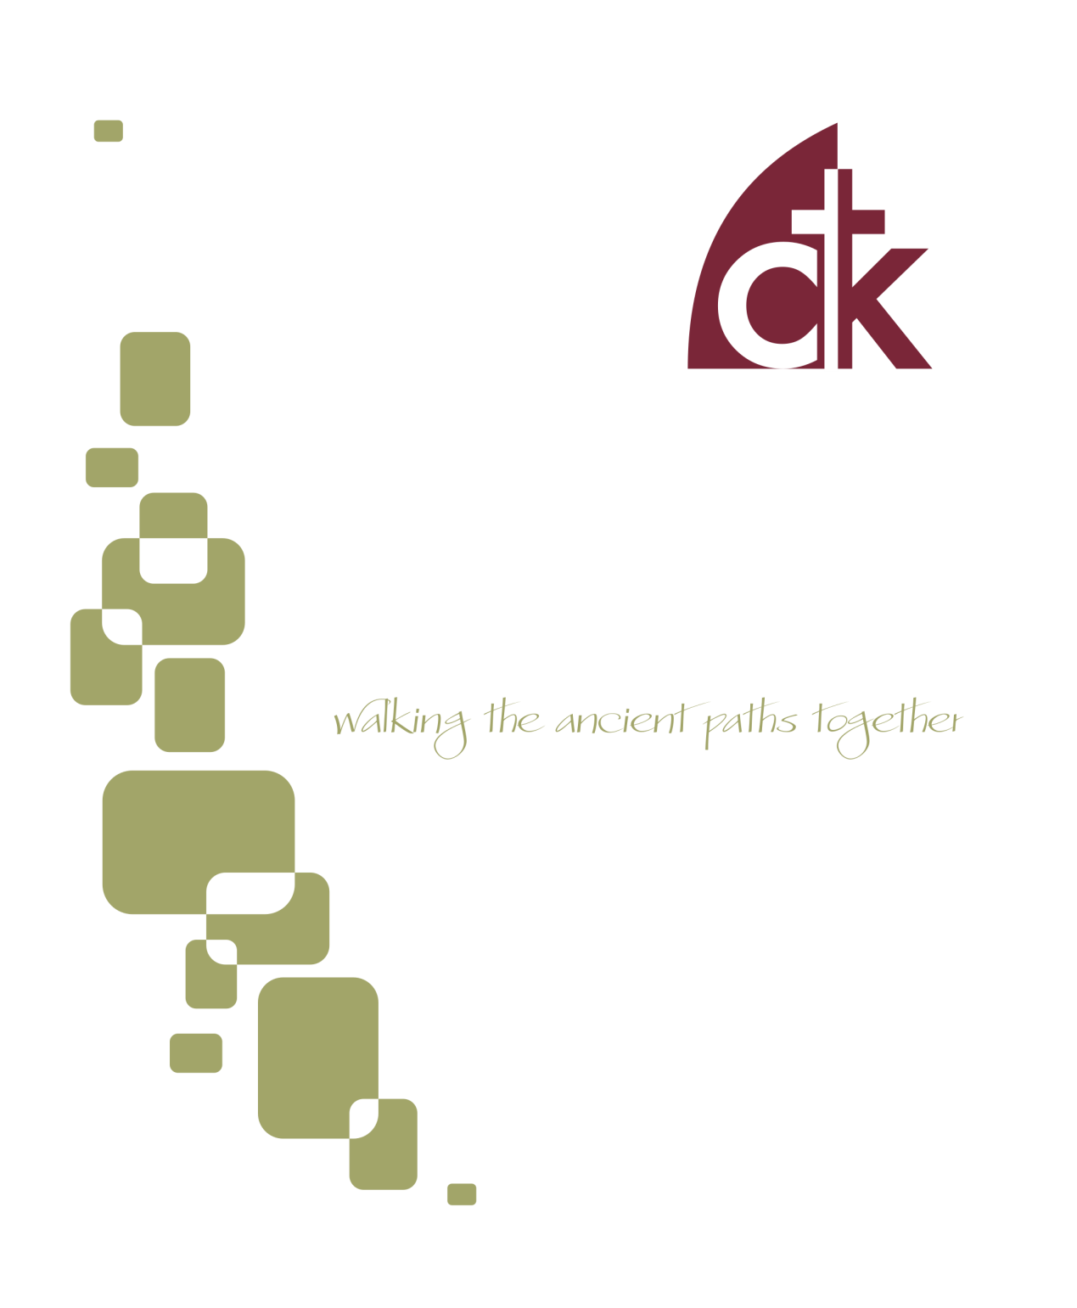
August 2016 Newsletter

We have lost the art of corporate prayer, which is a shame because corporate prayer is particularly blessed by our God.

The Problem with Corporate Prayer
At the root of the problem is that when we are engaged in corporate prayer—whether at the First Wednesday prayer meeting, or at one of our Home Fellowship Groups, or in Sunday worship—it is often the case that I’m not the one praying, and when we’re not praying, we lose interest. This is someone else’s prayer. It’s not really mine.
That’s the first idea that’s gotta go. When we are praying together we are praying with one another. One of us may be speaking and the others may be silent, but this is our prayer. Praying with other people means humbly allowing other people to pray on your behalf, to pray in your place. It means allowing them to intercede for you in the act of praying. When you are gathered, their prayer is your prayer--you are doing this thing together. My duty, then, is to hear, acknowledge, receive, and add my amen (not necessarily literally) to that which is being said.

Prayer Isn’t Just Private
Surely, though, private prayer is more important that corporate prayer? Surely I’m “closer” to God when it’s just me pouring out my heart?
Private and personal prayer is of course important and necessary. Jesus tells us that “your Father who sees in secret will reward you” for unseen and personal deeds of piety, and so he instructs us to “go into your room and shut the door and pray to your Father who is secret” (Matt. 6:6). However, religion is not a merely private affair, though sometimes we like to think it is. Jesus wants us to pray with and for one-another. It is therefore no accident that when he provides for us a model prayer, it begins with the words “our Father.” Our Father. The prayer assumes it is being prayed by a crowd.
What is more, Jesus elsewhere reminds us that this kind of prayer is particularly blessed. “Again I say to you, if two of you agree on earth about anything they ask, it will be done for them by my Father in heaven. For where two or three are gathered in my name, there am I among them” (Matthew 18:19-20). Thus the early church gathered together for prayer, putting into practice Jesus’ encouragement to do these things as a body, and not just in the privacy of our own homes (Acts 2:42).

The Power of Corporate Prayer
Why is corporate prayer so important? What effect does it have? Is it more powerful than private prayers?
When we say that corporate prayer is particularly blessed, we don’t mean that it is somehow “more powerful.” It’s not that corporate prayer is “louder” and so God is more likely to hear it, nor is there some kind of special magic in it. God is present with us in private prayers, and our private prayers are heard by God and answered by him in accordance with his will.
Nevertheless, corporate prayers have a number of effects that private prayers, by their very nature, do not. It’s similar to music. There is beauty in the solo, the sonata, the aria; but there is a different kind of beauty in the choir or the orchestra. They provide a form of expression not available to the individual (and, of course, the lone violist can accomplish things that an orchestra cannot—there is a beauty appropriate to each).

There is beauty in the solo, the sonata, the aria; but there is a different kind of beauty in the choir or the orchestra.
So what are some of the advantages of corporate prayer? Here is an incomplete list to prime our thoughts (and I would delight to hear some of your answers as well).
- Corporate prayer intensifies our petitions, our praises, our confession—all of our prayers. They add a weightiness to it. There is great mystery here, but what we can say for sure is that God is delighted with us when we function as a body, when we are of one mind, and when we approach him together.
- Corporate prayer supplements our weaknesses. We all have different perspectives, concerns, and gifts. For example, some of us are able to remember everything that’s going on, and others are more forgetful. Some of us understand what a certain experience is like and can therefore more effectively intercede for a person going through it, while others have never had that experience and don’t know how to pray. When we pray as a group we are able to limit the effect of our weaknesses and pool our strengths. We are greater together that we are individually.
- Corporate prayer both demonstrates our need for one another—our interdependence—and simultaneously fills that need. We are told time and again in Scripture that we need one another, that we can’t do this alone. Remember that Jesus himself asks for his disciples to pray with him (Matt. 26:36-46)! Corporate pray is both a humble recognition of that and also a fulfillment of the call to serve one another.
- Corporate prayer furthers our fellowship. Praying for someone binds you together—it makes you more a part of their lives and engages you in a common cause. Praying with someone does all of that even more powerfully. Don’t just pray for other people—particularly other people you care about and want to cultivate a friendship with—pray with them.

Praying for someone binds you together—it makes you more a part of their lives and engages you in a common cause. Praying with someone does all of that even more powerfully.
- Corporate prayer creates and expresses our unity. We are one people Paul says, and when we pray we demonstrate that unity. What is more, we cultivate it. By His Spirit God binds us together in the act of praying.

Pray with other People
So commit to praying with other people. Corporate prayers don’t have to be long affairs. Pray short prayers. Pray with your spouse and children. With your Sunday School students. With the person next to you in the pew. Make every effort not to zone out during the pastoral prayer on Sunday, but rather add your (silent or audible) amen. Join us on First Wednesdays for our prayer meeting—your presence adds to the blessedness of that time. For in all of this we approach God as “Our Father,” and he hears his people.

- Tommy

Reception for Justin and Gabriella Proffit
Please join us after morning worship on August 7th for a Potluck Lunch. We will be having a farewell reception for the Proffitts. Please bring an entrée or a side dish to share. The church will provide dessert. Avoid using nuts, nut products, or shellfish due to allergy concerns.

Food Collection
Thank you, CTK family, for contributing monthly to the Colonial Neighborhood Council's food cupboard! Your faithful donations of non-perishables are a blessing to the community. Now that school is closed people have to feed their school aged children and it puts an additional strain on the families because the students don't get free breakfast or lunch at school, and the summer months are also a slow time for donations. Please give generously to the CNC. If you have any questions, please feel free to contact either Lauren Elban or Michele Eichert. The next collection is August 21st!

Baby Shower for Stephanie Newman
Ladies of CTK, please join us for a baby shower for Stephanie Newman on Tuesday evening, 8/16, 7:00pm. The shower will be at 33 Aiken Ave Berwyn, PA 19312. Email Karen Watkins (karen.m.watkins@comcast.net) or rsvp: http://bit.ly/2awyatQ

Baby Shower for Caroline Carter
Ladies, please join us for a baby shower for Caroline Carter on Saturday August 27th at 10am! The shower will be at the Kirkland’s home. Please RSVP to rebeccak@christthekingpca.org

Labor Day Picnic
The Erickson family has graciously invited everyone to their house for a Labor Day picnic on Monday, September 5th from 11-4pm (lunch will be at noon). Come when you can, leave when you must for lunch and lawn games. The Erickon's will provide meat for grilling, and a signup sheet for sides will be coming via email. Please RSVP to carole.erickson@verizon.net with the number attending. We are looking forward to hosting as many as can come. Parking will be explained when you arrive. 571 Gulph Road Wayne 19087

Youth Group River Party
Join us Saturday September 10th for a party on the river! The Kirklands and Jay and Carmen Signorino will be hosting us for a time of food, fellowship, and river-related fun and games. The festivities will begin at 11:00 am and continue until 4:00. We will start with a cookout, so bring an appetite, sunscreen, a swimsuit, cheap sunglasses, towels and any games or activities you'd like to share. All Middle School and High School students and their families are welcome to join in the fun. Parents or appointed guardians are responsible for the safety of their children, and we could also use a couple of Dad volunteers to keep an eye on river activities. RSVP to Tommy Keene (tommyk@christthekingpca.org).

Lady’s Summer Bible Study
Join the women of the church for bible study, prayer, and fellowship Wednesday mornings, 9:30am – 11:00 am from June 22 to August 3rd (in the church office). Using the book, The Envy of Eve, Finding Contentment in a Covetous World by Melissa Kruger as a discussion starter, we will explore the Scriptures to understand what coveting is and what it is not, the reasons we covet, the patterns that coveting takes in our lives, and how Christ can give us a new pattern so we can experience contentment. “The hope of this book is to expose the sin of covetousness, showing the truth of Proverbs 14:30, ‘A heart at peace gives life to the body, but envy rots the bones.’” For more information and to have a book ordered for you, please contact Deb DeLecce, ddelecce@aol.com . Child care provided.

Work Day Service Opportunity
Calling all first-class painters and painter wannabes! The deacons are holding a couple of “paint & tidy up days” in August. We will be painting and tidying up the front 2 classrooms at the church office building (117 E. 4th Street, Conshohocken) on the last 2 Saturdays in August – Saturday, August 20 and 27. We will begin at 9 am both days and will paint & tidy up as long as we have energy to do so. We don’t plan on going past 2 pm on either day. All are welcome! Any questions, please see any of the deacons.

Men’s Book Study
The men will be meeting on Saturday August 6th from 8:00 AM to 9:30 AM in the church office building at 117 E. 4th Ave. We are currently discussing the book "Ordinary" by Michael Horton. If you would like a copy of the book, or have other questions about this ministry, contact Rich DeLecce. (ddelecce@aol.com).

Spring Mill Ministry
One Sunday each month, members of Christ the King meet with residents of Spring Mill retirement community for fellowship, hymn singing, and studying God’s word. Our friends in this community enjoy this time, especially since they are not able to get out and attend church at this stage of life. It also provides a way care for widows. Please contact Peter Stahl if you are interested in joining one Sunday and/or join us on May 22nd.

Sunday School in July and August
As is our tradition, we will be taking a break from our normally scheduled Sunday School program in July and August. We are looking forward to our September launch!
.

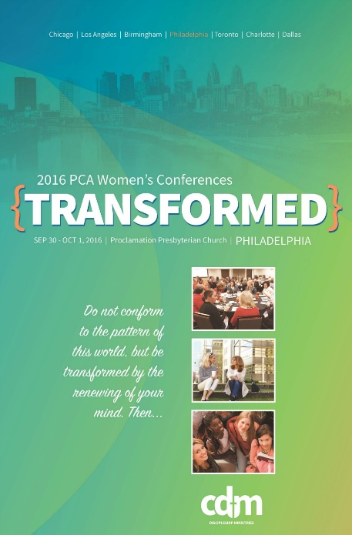
Ladies and teen girls, this fall, in lieu of our own CTK Women’s Retreat, we will be joining other PCA women in the northeast region for the “Transformed” conference to be held at Proclamation Presbyterian Church, September 30-October 1.

We invite all women (Ages 14, 40, or 104!) to join us as we seek to be TRANSFORMED through studying Romans 11:33-12:2 together. The keynote speaker for the northeast region is Melissa Kruger. Melissa Kruger serves on staff as Women’s Ministry Coordinator at Uptown Church (PCA) in Charlotte, North Carolina and is the author of The Envy of Eve: Finding Contentment in a Covetous World and Walking with God in the Season of Motherhood. In addition to keynote talks, breakout workshops will also be presented.

Schedule: Friday, September 30, 7 pm to 9 pm

Saturday, October 1, 9 am to 2 pm (includes lunch and 2 workshops)

Workshop Choices:

Flourishing: How the Gospel Changes Everything – Steph Hubach

How to Think Biblically about My Body – Ellen Dykas

How Do I Get Enough? – Callie Miller

Living with Purpose on Purpose in the Afternoon of Life – Sharon Betters

Talking to Kids about Tough Topics – Julie Lowe

More information is available at http://www.pcacdm.org/transformed2016/transformed-philadelphia

Stay tuned for registration information at a reduced price.

Praise God for a Safe and Successful Mission Trip
We give thanks to God for the safe return of four of our High School students—Ben Palmer, Nate Palmer, Lucas Carole, and McKenna Canale—from the Dominican Republic to serve a church in Juan Thomas through teaching and construction work. Thank you to everyone who contributed to and prayed for the trip! If you get a chance, grab one of these students and ask them about it—hearing stories of faithful service is one of the ways God uses to encourage and grow the body. You can also find more information at their blog: http://ppcdrtrip.blogspot.com.
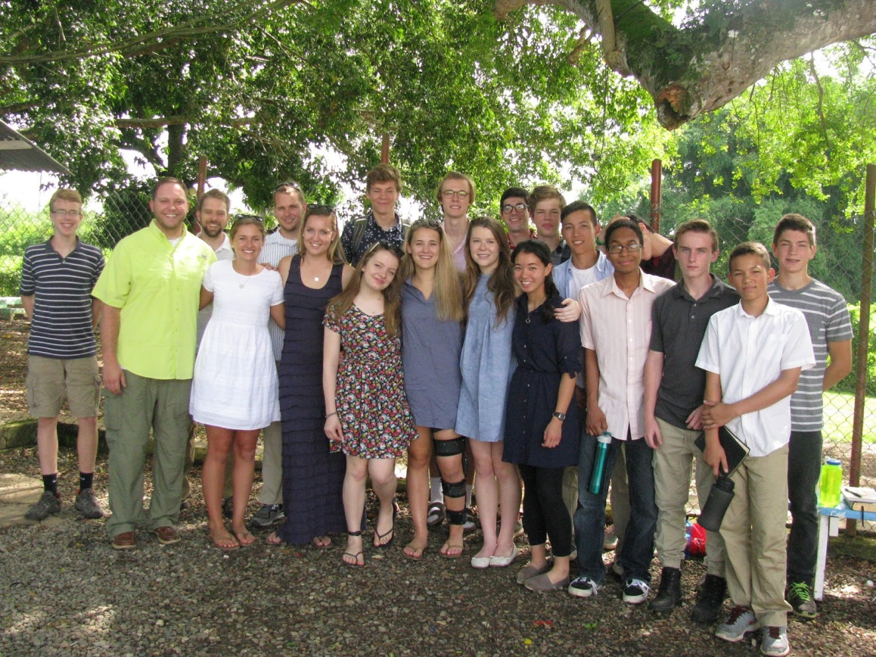

Thank You from Rachel Yonan
Dear Ladies of CTK,
Thank you all for the beautiful brunch that you had for me as we prepared to welcome our second son. What an encouragement to have time to visit with you, to hear hilarious anecdotes from more experienced moms and just have a great time of delicious food and fellowship! Thanks especially to Nicole Canale for hosting the brunch. It means a lot to us to have a church family that is so supportive.
Warmly,
Rachel Yonan

Now is the Time to Gather Operation Christmas Child Supplies
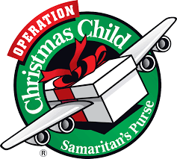
We will be continuing our tradition of a shoebox packing party this year in November. November seems like a long way off, but actually right now is a great time to start collecting things for the shoeboxes! There are tons of Back-to-School items on sale right now, and Samaritan’s Purse heartily recommends those kinds of items as gifts. For more information visit their website. Here are a few of their suggestions:
- School Supplies: pens, pencils and sharpeners, crayons, markers, notebooks, paper, solar calculators, coloring and picture books, etc.
- Non-liquid Hygiene Items: toothbrushes, bar soap, combs, washcloths, etc.
- Accessories: T-shirts, socks, hats, sunglasses, hair clips, jewelry, watches, flashlights (with extra batteries), etc.
- Crafts: Make your own items such as hair bows, finger puppets, and friendship bracelets.

Sunday School. CTK offers bible teaching tailored for each stage of life. K-5 meets in the church office (117 4th Avenue; teachers will direct your child to the specific room for their age), Middle School and Senior High are on the top floor of the church building, and Adults are on the main floor. Contact: Tommy Keene
First Wednesdays. Prayer and fellowship are an important component of body life. On the first Wednesday of every month we gather at the church to share a meal together and pray for one another. Contact: Eric Huber
Youth Group. We offer programs for Middle School and Senior High students designed to encourage fellowship, family life, and spiritual growth. Our regular meetings are on the First Wednesday of every month (see above), but we also have a number of opportunities throughout the year, including a Winter Ski Trip, Spring Retreat, Summer Missions Trip, Fall Picnic, and intermittent game nights. Contact: Tommy Keene
Home Fellowship Groups. Bible studies and fellowship groups meet in homes throughout the area. These groups provide a great way to connect with neighbors and friends, to grow in our common faith, and to pray for and disciple one another. You can contact Tommy Keene if you’re interested in finding a group, or talk to one of the leaders below.
Mike LoRusso leading at the Stahl’s home in Wayne at 6:45pm. (2nd and 4th Tuesdays)
Tommy Keene leading at the Kirkland’s home in West Norriton at 6:00pm (2nd and 4th Wednesdays).
John Erickson leading at the Erickson’s home in Valley Forge at 7:00 p.m. (2nd and 4th Wednesdays).
Choir and Music. Music is a fundamental component of our worship, and we strive for excellence as we offer our sacrifice of praise to the Lord. “I will sing and make melody with all my being! Awake, O harp and lyre! I will awake the dawn!” If you are interested in participating in this ministry, either with song or instrument, contact our music director, Justin Proffitt.
First Sunday Potlucks. We regularly feast together immediately after morning worship on the first Sunday of every month. Bring a meal to share (but join us anyway if you forgot!). If you are interested in helping with our food and kitchen ministry, contact Barbara Lorusso.

Women in the Church (WIC). WIC seeks to assist the women of the church to honor and love God and serve one another in love. Our mission is to care for women, to integrate new women into the life of the church, and to promote fellowship, mercy, and Bible study opportunities. We are often are looking for people to host events, or make meals for a church family in need, or planning and detail help with any of the above. Contact us atwic@christthekingpca.org or by speaking with Dana McGahey.
Men's Book Study. The men meet on the first Saturday of each month from 8:00 AM to 9:30 AM in the church office building at 117 E. 4th Ave. We are currently discussing the book Ordinary by Michael Horton. If you’d like a copy of the book, or have other questions about this ministry, contact Rich DeLecce.
Nursery. Christ the King offers nursery services for all children under the age of 5 (or 6 for evening services and special services) during all morning and evening worship services, as well as for Sunday School and most special services. Our volunteers are dedicated, caring, and hard workers! Even at a young age our children are forming bonds of fellowship that they will value and rely on for years to come, and our nursery volunteers are dedicated to promoting those relationships. This isn’t just “babysitting,” it’s ministry! If you have questions about how the nursery functions, or would like to serve in this important ministry, contact Maria Signorino.
Greeters and Ushers. Hospitality is important to us! Our greeters and ushers are in charge of welcoming people into our church home and helping out with any needs that come up during the service. If you’re interested in helping this area, contact Tommy Keene.

God has been pleased to provide care for his church through the ministry of elders. In the PCA, we have both ruling and teaching (pastors) elders. The elders seek to care for the church together as a session, and through personal connections with the members of the church. Some key passages in Scripture that describe this care are found in Luke 22:24-27, John 21:15-19, Acts 20:17-38, 1 Tim 3:1-7, Titus 1:5-9, Hebrews 13:8, 17 and 1 Peter 5:1-5. Our session has divided the members of Christ the King into four shepherding groups, each assigned to one of our four ruling elders. Our hope is that this will be a valuable component of caring for one another and growing together in the faith. You can expect your elder to pray for you, get to know and love you, assist you in your Chris-
tian walk, to be available and to visit or call you at least once a year. Please be in prayer for your elder and for all the session (Hebrews 13:18), and please let your elder know of any special prayer needs or ways that they can serve and shepherd you well.

Rex Anderson | Rich DeLecce | Ray Doreian | Mike LoRusso
Canale family | Blackburn family | Azzarano family | Ian & Erin Buchanan
Carroll family | Carter family | Erickson family | Elban family
Davis family | Kathy Daly | Ghrist family | Helfand family
Eichert family | Debbie Doyle | Susan King | Hoffman family
Nate Huber | Theresa Gantz | McGahey family | Jack & Stephanie Newman
Erin Imbert (Eastlack) | Dani Huber | Ritter family | Charlotte Schmucker
Kirkland family | Hudson family | Joy Signorino | Jay & Carmen Signorino
Neikirk family | Ludlam family | Terry Smith | Stahl family
Palmer family | Schneider family | Thistlewaite family | Sharon Tobin
David Penning | Chip & Maria Signorino family | Christine Wazynski | Watkins family
Justin & Gabriella Proffitt | Kate Simons
Tyson family | Jen Vare
Yonan family | Neil Leone

 | August 7 | August 14 | August 21 | August 28
Greeters  4th Ave | Anna Ludlum | Nicole Davis | Elizabeth Stahl | Rich/Debbie DeLecce
Greeters Fayette Street | Debbie Doyle | Ray Doreian | Kathy Daly | Charlotte Schmucker
Set Up | Jerry Davis  Pat Canale | Jay Signorino  Nic Kirkland | Dave Hudson  Dan Hoffman | John Erickson  Tom Blackburn
Ushers | Jay Signorino  Mark Hoffman  Dave Ritter  Josh Tyson | Jerry Davis  Pat Canale  Dan McGahey  Peter Stahl | Dave Hudson  Chip Signorino  Rob Ghrist  Tom Blackburn | Dave Ritter  Jack Newman  Dave Hudson  John Erikson

Sunday School Nursery
Morning Nursery | Michelle Eichert  Pat Canale  Luka Canale (Maria Signorino) | Christine Hoffman  Renee Blackburn Josh Blackburn (Liz Hudson) | Ian Buchanan Erin Buchanan Maria Signorino (Rebecca Kirkland) | Liz Hudson Anna Ludlum Mark Stahl  (Pat Canale)
Evening Nursery | Josh Tyson  Lucy Tyson | Peter Stahl Elizabeth Stahl | Terry Smith  Lauren Huber | Jay Signorino  Carmen Signorino

The context of these verses is about repentance, but the principle Jesus lays out here applies more broadly. The

