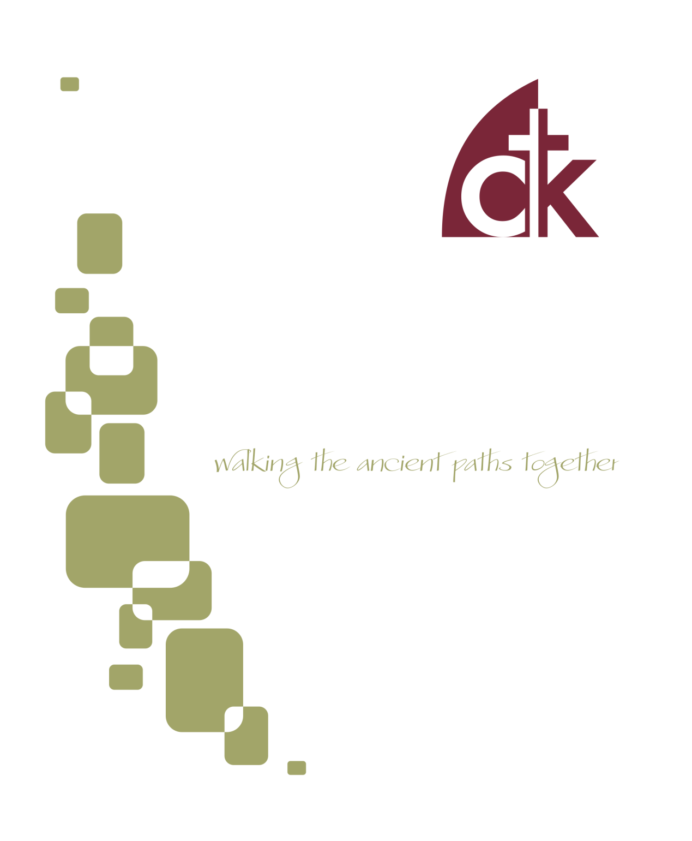
February 2017 Newsletter

Pilgrims in the Wilderness
It’s no accident that we sometimes call the Christian Life a “pilgrimage.” It’s a common metaphor, of course. Life, after all, is a journey, an adventure. I choose a path; I walk a way; I march to some particular beat. We are travelers, or wanderers, or pilots. This is how we talk about life, and this is also how the Bible describes the Christian Life. In fact, if you want to understand the Christian life—What difficulties should I expect? What goal should I pursue? Is there somewhere I can go for help?—then may I humbly suggest the book of Hebrews? It gives you a central metaphor to think about your life as a Christ-follower: you are a wilderness wanderer; you are a pilgrim seeking a promised land.

Wilderness Wanderers
I have been preaching through the book of Hebrews in our evening service, and I can tell you quite honestly, I am both excited and terrified. On the one hand, this is my bread and butter, my favorite book, the thing I have been studying my entire professional life; and yet, precisely for all those reasons, and more besides (it is, after all, God’s Word), it has proven to be an incredibly humbling sermonic topic. It’s the book about which I have the most questions, and within which I find the most personal encouragement. How to plumb the depths?
Take, for example, the most basic of questions: to whom is this book written? Obvious, right? It’s right there in the title: “to the Hebrews.” Not so fast! Remember, the titles of our Biblical Books are not, strictly speaking, “biblical.” They are traditional, and though they are generally reliable, they are not inspired by God. They are added by later copiers. Therefore, the contents of the book, rather than the title, should drive any conclusion about its audience. The problem, though, is that, unlike, say, the Epistle to the Romans (Rom. 1:1; 15:22-29), Hebrews gives us precious little about its audience. They are second generation Christians (Heb. 2:3), they have been persecuted but not martyred (Heb. 12:4), and they are probably not living in Rome (Heb. 13:24). Other than that, we don’t know much. Yet, perhaps this lack of information is not so bad.

“Do not harden your hearts as in the rebellion, on the day of testing in the wilderness” (Heb. 3:8).
Though we have no specific information, we have a TON of general information. We actually know exactly how our author thinks about his audience. Who are they? What makes them tick? What makes their lives difficult? What gives them joy and what causes them pain? The answer to all those questions is summed up in one profoundly productive metaphor: “Today, if you hear his voice, do not harden your hearts as in the rebellion, on the day of testing in the wilderness.”
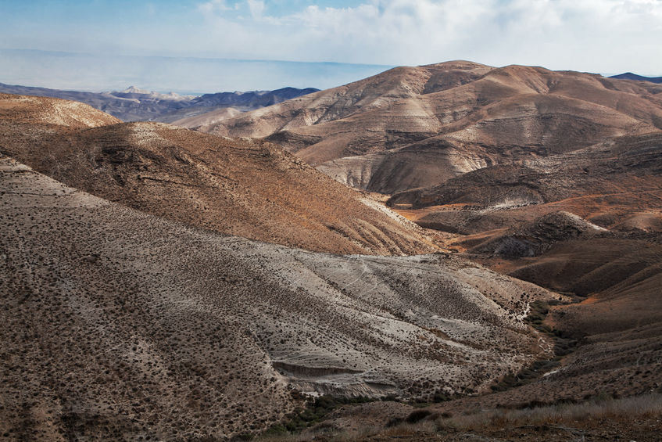
How is that helpful? If you are not immersed in the stories of the OT, it may not be immediately inspiring to you, but the author of Hebrews is actually telling his audience something very important about their life and context, about who they are. He is taking an OT story—the story of Israel in the wilderness—and applying it to their life. You are like them; your situation is like their situation; your goal is their goal. Like Israel of old, you have been delivered from Egypt and set free to serve your God. Like Israel of old, you are pursuing Promised Land. Like Israel of old, you are walking the ancient paths, following after your God as he guides you from Egypt into Promised Land. Like Israel of old, you journey with God through a wilderness.
The fact that the author is so general allows us to more easily see how this applies to us. The Christian Life isn’t sometimes a wilderness; it’s not a wilderness because of some specific set of circumstances, or because in some ways we resemble 1st century Jews or Romans. It’s a wilderness because we follow Christ. To follow Jesus is to journey with God through a wilderness.

The Christian Life
It may seem bleak, but that, sisters and brothers, is the Christian life. We are out of Egypt and we pursue the Promised Land, but right now we are pilgrims in the wilderness. Furthermore, God instructs us how to survive this wilderness life: “do not harden your heart…on the day of testing in the wilderness.”
Why such an exhortation? Because the wilderness is a dangerous place. Israel, you will remember, fell in the wilderness (Num. 16, 1 Cor 10). The first generation failed, and though God was faithful to His promises and brought the next generation through, the first generation perished in the wildness. Why? Because they allowed their hearts to harden. They succumbed to temptation.
This is not a uniquely OT danger; Jesus himself reminds us of this: remember that only one out of four seeds bore fruit (Matt. 13:1-23). We are surrounded by temptations and the cares of the present age. Apathy sets in; old sins renew their onslaught; the world presses down upon us; we begin to “drift away” (Heb. 2:1).
How should we then describe the Christian life? What is our challenge, and what is our goal? We seek to persevere in the wilderness. We are pilgrims, searching for Promised Land, beset by numerous temptations to turn aside. What is success? In a word: perseverance.

Pilgrims without a Pilgrimage
Perseverance is hard; the wilderness is dangerous. Is their hope for us? How do we persevere to the end? The answer: only by the power of Jesus Christ.
Here’s the remarkable thing: though we are pilgrims, like the Israelites of old, seeking a holy rest and a most holy place, nevertheless, we are pilgrims who, unlike Israel, make no pilgrimage. Let me explain. Now that the Jesus has come, we have access to a greater Holy Place, in comparison to which the old Temple was but “a copy and a shadow” (Heb. 8:5). “We have such a high priest, one who is seated at the right hand of the throne of the Majesty in heaven, a minister in the holy places, in the true tent that the Lord set up, not man” (Heb. 8:1-2).

“We have such a high priest, one who is seated at the right hand of the throne of the Majesty in heaven, a minister in the holy places, in the true tent that the Lord set up, not man” (Heb. 8:1-2).
And notice that this holy place is not a temple, but a tent. Why? Because tents are movable and temples are not. Wilderness wanderers need a tabernacle, not a temple. God does not require us to make a pilgrimage to take advantage of the power of His Presence; God comes with us on the journey. Is there hope for us? Yes, because Christ is always near! “Let us draw near with a true heart in full assurance of faith” (Heb. 10:22). Since Christ has come down and dwelt among us, since he has sent his Spirit to dwell within us, we are now and forevermore “in Christ.” Do you need Spiritual water for your journey? Refreshment? Encouragement? Draw near in prayer, corporate worship, word and sacrament, for in these things the ministrations of Christ Himself are provided to you by the power of His Spirit.
- Tommy

Sunday School Open House
There will be a Sunday school open house on February 19th. Parents and guest are welcome to join their children in the Sunday school classroom that day.
Fellowship Dinner and Congregational Prayer
On February 1st there will be a fellowship dinner and congregational prayer meeting. The dinner begins at 5:30 pm and is provided by the church The adults meet for prayer from 6:30-7:30 pm and youth aged middle school and above will meet upstairs for a time of singing, prayer, and teaching. On the 2nd and 4th Wednesdays, Home Bible Fellowships meet throughout the area.

Men’s Book Study
The men will be meeting on Saturday February 4th from 8:00 AM to 9:30 AM in the church office building at 117 E. 4th Ave. We are currently discussing the book "Ordinary" by Michael Horton. If you would like a copy of the book, or have other questions about this ministry, contact Rich DeLecce. (ddelecce@aol.com).

1st Sunday Potlucks
WIC will be hosting a potluck on the first Sunday of the month. Please join us February 5th for this time of fellowship after the morning service. Please bring an entrée or a side dish to share. Avoid using nuts, nut products, or shellfish due to allergy concerns.
WIC Baby Shower
All women of the church are invited to a Baby Boy Shower Brunch honoring Erin Buchanan, on February 11, from 10:00-12:00, at the home of Charlotte Schmucker, (429 Waynesbrooke Rd, Berwyn). Please RSVP to Maria at 603-661-8452.

Women’s Saturday Morning Bible Study
The Saturday Morning Bible Study will be meeting at Maria’s home on February 18th at 9:30 am. Our study is ‘The Promised One’, Seeing Jesus in Genesis, by Nancy Guthrie. If you have any questions, please call Charlotte Schmucker at 610-647-1362.

Dominican Republic Mission Trip
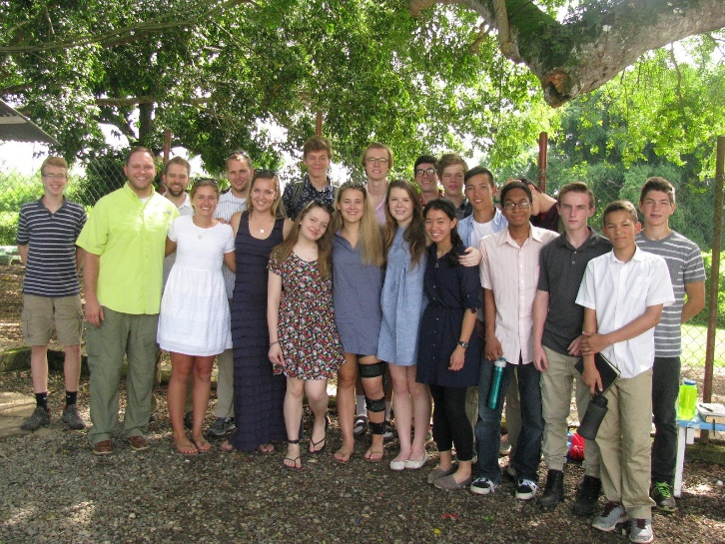
It's time to start planning for the 2017 mission trips. This year even more churches within our Presbytery will be participating--it's been exciting to see this mission opportunity grow and flourish!
The trip this year will be June 20-28th, continuing the gospel ministry that has been taking place for the last 7 years in the village of Juan Thomas. As in previous years, we plan on doing construction work in the morning and early afternoon of each day that our team is serving there. Our prayer is that the Lord would assemble a group of committed and humble servants to form a team united in the good news of our Lord Jesus Christ.
If your High Schooler is interested in applying for the trip, please notify Tommy ASAP and send in your application by Feb. 8 (tommyk@christthekingpca.org).

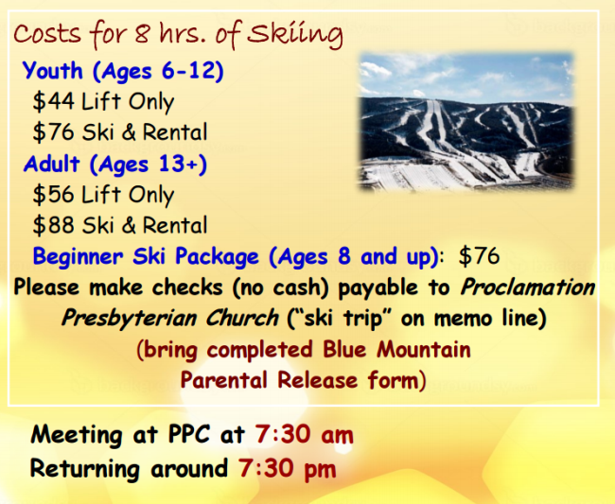
Family Ski Trip
All families are invited to our annual Ski Trip to Blue Mountain on February 4th. We are in need of chaperones at all skiing levels, so let Tommy know if you are interested in helping out.
We will be meeting promptly at 7:30 am at Proclamation Presbyterian, at which time all forms should be filled out.

Sunday School. CTK offers bible teaching tailored for each stage of life. K-5 meets in the church office (117 4th Avenue; teachers will direct your child to the specific room for their age), Middle School and Senior High are on the top floor of the church building, and Adults are on the main floor. Contact: Tommy Keene
First Wednesdays. Prayer and fellowship are an important component of body life. On the first Wednesday of every month we gather at the church to share a meal together and pray for one another. Contact: Eric Huber
Youth Group. We offer programs for Middle School and Senior High students designed to encourage fellowship, family life, and spiritual growth. Our regular meetings are on the First Wednesday of every month (see above), but we also have a number of opportunities throughout the year, including a Winter Ski Trip, Spring Retreat, Summer Missions Trip, Fall Picnic, and intermittent game nights. Contact: Tommy Keene
Home Fellowship Groups. Bible studies and fellowship groups meet in homes throughout the area. These groups provide a great way to connect with neighbors and friends, to grow in our common faith, and to pray for and disciple one another. You can contact Tommy Keene if you’re interested in finding a group, or talk to one of the leaders below.
Mike LoRusso leading at the Stahl’s home in Wayne at 6:45pm. (2nd and 4th Tuesdays)
Tommy Keene leading at the Kirkland’s home in West Norriton at 6:30pm (2nd and 4th Wednesdays).
John Erickson leading at the Erickson’s home in Valley Forge at 7:00 p.m. (2nd and 4th Wednesdays).
Choir and Music. Music is a fundamental component of our worship, and we strive for excellence as we offer our sacrifice of praise to the Lord. “I will sing and make melody with all my being! Awake, O harp and lyre! I will awake the dawn!” If you are interested in participating in this ministry, either with song or instrument, contact our music director, Bonnie Hoffmann.
First Sunday Potlucks. We regularly feast together immediately after morning worship on the first Sunday of every month. Bring a meal to share (but join us anyway if you forgot!). If you are interested in helping with our food and kitchen ministry, contact Barbara Lorusso.

Women in the Church (WIC). WIC seeks to assist the women of the church to honor and love God and serve one another in love. Our mission is to care for women, to integrate new women into the life of the church, and to promote fellowship, mercy, and Bible study opportunities. We are often are looking for people to host events, or make meals for a church family in need, or planning and detail help with any of the above. Contact us atwic@christthekingpca.org or by speaking with Dana McGahey.
Men's Book Study. The men meet on the first Saturday of each month from 8:00 AM to 9:30 AM in the church office building at 117 E. 4th Ave. We are currently discussing the book Ordinary by Michael Horton. If you’d like a copy of the book, or have other questions about this ministry, contact Rich DeLecce.
Nursery. Christ the King offers nursery services for all children under the age of 5 (or 6 for evening services and special services) during all morning and evening worship services, as well as for Sunday School and most special services. Our volunteers are dedicated, caring, and hard workers! Even at a young age our children are forming bonds of fellowship that they will value and rely on for years to come, and our nursery volunteers are dedicated to promoting those relationships. This isn’t just “babysitting,” it’s ministry! If you have questions about how the nursery functions, or would like to serve in this important ministry, contact Maria Signorino.
Greeters and Ushers. Hospitality is important to us! Our greeters and ushers are in charge of welcoming people into our church home and helping out with any needs that come up during the service. If you’re interested in helping this area, contact Tommy Keene.

God’s People in the Wilderness by O. Palmer Robertson
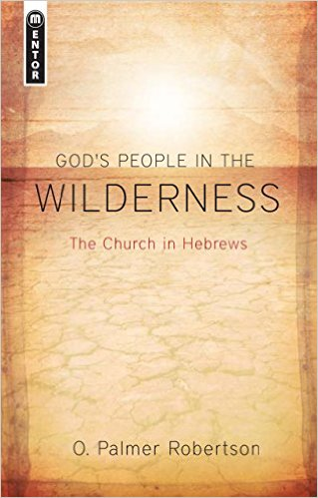
Looking for more on the wilderness theme in Hebrews? This is a great resource. It examines some of the matters mentioned previously, while also mapping that on to the life of the church. The book definitely has a theological emphasis, but Robertson is not afraid to tease out practical implications along the way.
If you’re familiar with Robertson you would expect him to put all this theology into a covenantal framework, and he doesn’t disappoint. There is a lot of great analysis of the relationship between the covenants and the similarities and differences between our experience of the wilderness and that of Israel.
It’s a short book, and though the language is a bit terse, it is not difficult to read. It’s a great resource for any who want to explore the central metaphor of this wonderful epistle.

Commentaries on Hebrews
For those looking for a more traditional commentary, I have several recommendations. My go-to is William Lane’s, but it’s a bit technical. Bruce is excellent. Tom Schreiner has a new commentary that has proven comprehensive and readable, taking advantage of many recent insights (like those of Lane), while remaining for the most part non-technical. Schreiner also does a good job of interpreting Hebrews within its biblical context. Hughes is a bit dated, but still very helpful and insightful. Rick Phillips has a commentary in the Reformed Expository Commentary series that is self-consciously Reformed in its orientation
Though I don’t agree with everything he says, George Guthrie’s commentary in the NIV Application series is a helpful and readable contribution. It’s also a nice balance of exegesis, theology, and practice. You can also couple it with a wonderful study guide by Janet Nygren, Hebrews: Running the Race Before Us. It’s an excellent study guide and good for groups.

God has been pleased to provide care for his church through the ministry of elders. In the PCA, we have both ruling and teaching (pastors) elders. The elders seek to care for the church together as a session, and through personal connections with the members of the church. Some key passages in Scripture that describe this care are found in Luke 22:24-27, John 21:15-19, Acts 20:17-38, 1 Tim 3:1-7, Titus 1:5-9, Hebrews 13:8, 17 and 1 Peter 5:1-5. Our session has divided the members of Christ the King into four shepherding groups, each assigned to one of our four ruling elders. Our hope is that this will be a valuable component of caring for one another and growing together in the faith. You can expect your elder to pray for you, get to know and love you, assist you in your Christian walk, to be available and to visit or call you at least once a year. Please be in prayer for your elder and for all the session (Hebrews 13:18), and please let your elder know of any special prayer needs or ways that they can serve and shepherd you well.

 | Feb 5 | Feb 12 | Feb 19 | Feb 26
Greeters  4th Ave | Anna Ludlum | Nicole Davis | Elizabeth Stahl | Rich/Debbie DeLecce
Greeters Fayette Street | Debbie Doyle | Ray Doreian | Kathy Daly | Charlotte Schmucker
Set Up | John Erickson  Pat Canale | Jerry Davis  Dave Hudson | Jay Signorino  Nick Kirkland | Dave Hudson  Dan Hoffman
Ushers | Dave Hudson  Jay Signorino  Rob Ghrist  Tom Blackburn | Dave Ritter  Jack Newman  Dave Hudson  John Erickson | Jay Signorino  Mark Hoffman  Dave Ritter  Josh Tyson | Jerry Davis  Pat Canale  Dan McGahey  Peter Stahl
Sunday School Nursery | Clarice Helfand | Anne Schneider | Nicole Canale | Maria Signorino
Morning Nursery | Michelle Eichert  Anna Ludlum  Charlotte Schmucker  McKenna Canale | Chip Signorino  Maria Signorino  Josh Tyson  Hope Blackburn | Debbie Ghrist  Annie Christ  Christine Hoffman  Josh Blackburn | Liz Hudson  Lucy Tyson  Pat Canale  Luka Canale
Evening Nursery | Jay Signorino  Carmen Signorino | Terry Smith  Lauren Huber | Mark Elban  Lauren Elban | Peter Stahl  Elizabeth Stahl

