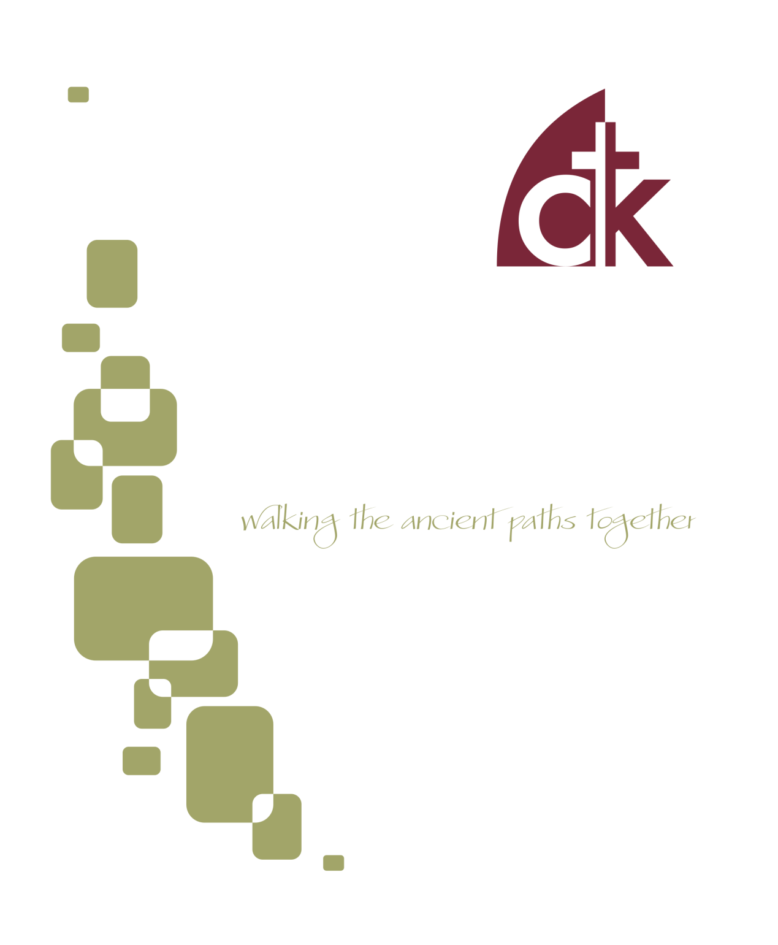
November 2016 Newsletter

Got the Election Day Blues?
Election day approaches, and I imagine that many of us are, to some extent, disappointed with some aspect of “how our country is doing.” I imagine that many of us are going to continue to be disappointed no matter the outcome on November 8. What do we do as Christians when we feel things are not going well?
Now this article isn’t about politics. Not really. It offers no instruction on how to vote, nor any solutions to our present political climate. It’s not a call to greater political involvement, or less political involvement. The question I want to address is more basic. What should my attitude be to the state, given the present climate? Should we be discouraged? Apathetic? Angry? Afraid? Antagonistic? What instruction and encouragement does the Bible offer us in the midst of our present social and political distress?

Remember: You are a citizen of a heavenly kingdom
In troubled times we need to go back to basic principles. Eric and I have both preached on this topic recently, and we also discussed it at a recent Sabbath Symposium, but it bears repeating because it is so important. We must remember that we Christians are first and foremost citizens of a heavenly Kingdom. We are followers of Christ. Our first allegiance is pledged to King Jesus, and not to the state. What is more, our identity and destiny is ultimately tied to the success of God’s kingdom, not to the kingdoms of this world.
Here’s how Peter puts it: “you are a chosen race, a royal priesthood, a holy nation, a people for his own possession, that you may proclaim the excellencies of him who called you out of darkness into his marvelous light. Once you were not a people, but now you are God's people; once you had not received mercy, but now you have received mercy” (1 Peter 2:9-10). It’s easy for our proximate identity to be mistaken for our ultimate identity, but Peter makes it clear: our heavenly citizenship is so central to who we are, that by comparison we are “strangers and exiles” in our earthly country (2:11-12). Peter wants us to so identify ourselves with the Kingdom of Christ that we consider ourselves resident aliens in our native land.

Remember: The Gospel is revolutionary
Does that mean we should stick our head in the sand and ignore the affairs of our country? Not at all! Though Jesus adopts us as Children of Heaven, he doesn’t call us “out of the world,” but rather sends us back into the world “as you [God] sent me into the world” (John 17:16-19). In other words, though we are Heavenly Citizens, we are also called to be such as resident aliens in the present world, that we may do what Jesus Himself was called to do: proclaim the Kingdom to the ends of the earth (Acts 1:8).

They are not of the world, just as I am not of the world. Sanctify them in the truth; your word is truth. As you sent me into the world, so I have sent them into the world (John 17:16-18).
So what does that look like? Peter tells us:
Beloved, I urge you as sojourners and exiles to abstain from the passions of the flesh, which wage war against your soul. Keep your conduct among the Gentiles honorable, so that when they speak against you as evildoers, they may see your good deeds and glorify God on the day of visitation (1 Pet. 2:11-12).
Though our situation is pretty complex and full of trials (1:7), nevertheless our duty is pretty straightforward. First, keep your own life pure and holy, confessing your own sins before your Heavenly Father and seeking to keep his Word by the Spirit of Christ. Second, behave honorably “among the Gentiles,” even and especially when they oppose you. Two sets of activities: love God, love neighbor. Sound familiar?
The little word Peter uses to describe our conduct among the Gentiles deserves a little unpacking. What does it mean for our conduct to be “honorable?” It means more than just “keep your nose clean.” It’s more than personal piety and morality—Peter already said we needed to do that in 2:11. It means engaging in the kinds of behavior that others would naturally praise, or treat with honor. It means things like hospitality, philanthropy, integrity. It means serving the city in a visible way such that others consider you a beneficent member of society. It’s not just driving the speed limit; it’s stopping and helping someone change their tire. Sacrificial service, even unto the Gentiles, and even when they are cursing us. That’s what Christ did, and the servant is not above the master.
That message, proclaimed in word, lived in deed—the message that Christ died for the ungodly, coming to serve and not to be served—turns the world upside down. Trust in the power of Gospel, for it is salvation for the Jew first, and also the Greek.

Remember: The church flourishes in opposition
Can we do those things in the present political climate? It seems increasingly difficult to proclaim the kingdom of Christ in word and deed these days. What’s more, if things continue the way they have been developing in recent years, will it be increasingly difficult for the church to pursue its mission? Will we face greater persecution? Will our liberties—particularly our religious liberties—be diminished and threatened? Will the values of the culture continue to diverge radically from the values of Bible-believing Christians? The answer to all of those questions seems to be “yes.” So how should we think about that?
Of course we should pray that these things don’t come to pass! But we should also prepare our hearts and minds for whatever the Lord brings our way. We need to remember that the Church continues to be the Church regardless of the situation within which it finds itself. What does that mean? It means that the power of the Church is the power of Christ, which in turn means that our ability to flourish is not tied to any social or political situation. Our success as the church is not tied to who becomes president, or what policies are coming down the pipeline, or whether or not religious organizations have tax-exempt status. The power of the church is not political, but Spiritual. The power at our disposal is the Word of God and the Work of Christ, and so our duty as Christians is to pursue the Kingdom through proclamation and service.
Opposition is not new; historically, very few Christians have enjoyed religious liberty. We would do well to remember that Rome was no friend to Christianity. We’ve been learning that in Acts! Don’t mistake polytheism for pluralism; Rome was brutally cruel to non-conformists. Hopefully we are not headed to a similar level of opposition, but here’s the point: our ability to flourish as Christ’s Church is not thereby hindered. In fact, for the earliest Christians, the opposite was the case; as the church was opposed, the Gospel flourished. Why? Because the Gospel is the power of God unto salvation.
Remember: it’s the kingdoms of this world that will, in the end, be toppled, but the gates of hell can’t prevail against the church. In the meantime, we love our neighbor; we become all things to all men, that by the grace of Christ we might save some.
- Tommy

Fellowship Dinner and Congregational Prayer
On November 2nd there will be a fellowship dinner and congregational prayer meeting. The dinner begins at 5:30 pm and is provided by the church. The adults and youth aged middle school and above will meet from 6:30-7:30 pm for a report from the Kirkland Family about their ministry in Athens, Greece. On the 2nd and 4th Wednesdays, Home Bible Fellowships meet throughout the area.
Thanksgiving Eve Service.
Join us for a time of worship and thanksgiving. Tis the seasons to give thanks! Of course, God commands us to give thanks in and out of season (Psalm 9), but what better time than Thanksgiving Eve, and what better place than gathered with God's people. Join us at 7pm for a time dedicated to thankfulness.
No Sunday School or Evening Service November 27. Join us for morning worship, but given the holiday we would encourage you to devote the evening to rest, family, and friends.

Men’s Book Study
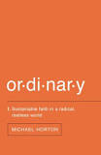
The men will be meeting on Saturday November 5th from 8:00 AM to 9:30 AM in the church office building at 117 E. 4th Ave. We are currently discussing the book "Ordinary" by Michael Horton. If you would like a copy of the book, or have other questions about this ministry, contact Rich DeLecce. (ddelecce@aol.com).

1st Sunday Potlucks
WIC will be hosting a potluck on the first Sunday of the month. Please join us November 6th for this time of fellowship after the morning service. Please bring an entrée or a side dish to share. Avoid using nuts, nut products, or shellfish due to allergy concerns.

Saturday Women’s Bible Study
The Women's Saturday Bible Study will be meeting on Saturday, November 19th at 9:30 am at the home of Sharon Tobin. We are studying The Promise One, Seeing Jesus in Genesis, by Nancy Guthrie. If you have any questions, please contact Charlotte Schmucker at 610-647-1362.

Food Collection
Back to school time and the food pantry could use its regular nonperishable items and any items for packing lunches, too! Please give generously to the CNC. If you have any questions, please feel free to contact either Lauren Elban or Michele Eichert. The next collection is November 20th!
WIC BRUNCH
There will be a women's brunch on Saturday, November 12th at the home of Carole Erickson. Please come fellowship and enjoy good food together! Sign up and more details to come!

Young Lives Christmas Gifts
This Christmas we are glad to be able to once again partner with YoungLives and provide gifts for mothers and children in the Norristown club. CTK has a long standing relationship with YoungLives, a ministry to teen mothers and their children. Beginning this month there will be a wreath at the back of the church decorated with gift tags which you can remove and use to purchase a gift for a teen mom or child. More details will be available as the time draws near. Please look at your bulletins or contact Lauren Elban with any questions (215) 740-2461

Operation Christmas Child Packing Party: November 13th
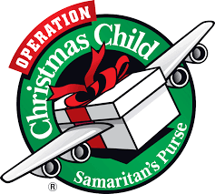
We will be continuing our tradition of a shoebox packing party on Sunday November 13th after the evening service (7pm).
The Packing Party is a great time for the whole family. Having collected appropriate gifts and goods, we gather after our evening service to pack shoeboxes for kids all around the world. The kids have a great time thinking through what they want their recipient to receive—it’s a wonderful and surprisingly personal way of teaching kids about the joy of giving. After it’s all done we watch a short classic holiday movie together, with ice cream and hot chocolate.
Want to participate? We are currently gathering donations and shoeboxes. You can bring both to church; leave them in the back behind the pews and let Tommy know!
What to donate? Here are a few of their suggestions (and you can also check out the website):
- School Supplies: pens, pencils and sharpeners, crayons, markers, notebooks, paper, solar calculators, coloring and picture books, etc.
- Non-liquid Hygiene Items: toothbrushes, bar soap, combs, washcloths, etc.
- Accessories: T-shirts, socks, hats, sunglasses, hair clips, jewelry, watches, flashlights (with extra batteries), etc.
- Crafts: Make your own items such as hair bows, finger puppets, and friendship bracelets.

On October 21, Christ the King's sanctuary rang with the sweet and sad sounds of Gospel soul during a community jazz concert featuring pianist Bill Edgar and renowned vocalist Ruth Naomi Floyd. Floyd's powerful vocals and Dr. Edgar's historical vignettes illuminated the deeply Christian roots of traditonal African American music: the beauty of Creation, the violence of the the Fall, and the glorious hope of Christ's Redemption. After the concert, audience members enjoyed a delightful reception with the musicians. Many thanks to everyone who contributed to this unforgettable evening.

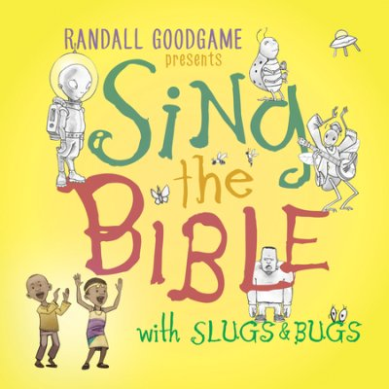
Sing the Bible (with Slugs and Bugs)
I was reminded recently of the important of memorizing Scripture. I was talking with a friend going through some difficult times and in the course of that conversation they said “You know, it’s been good to have some wonderful Scripture passages right there in my head to think on.” That’s one of the many benefits of Scripture memory. Those moments when we are struggling, or joyful, or at a crossroads, and pop! The verse we need is there in our head, ready for meditation, preparing us for prayer, provoking us on to good deeds. And, since you never know what you’re going to need, so your head should be a Swiss Army knife of Scripture.
Bible memorization is a good habit to cultivate at any age, of course, but kids are especially good at memorizing, and the habits you build when young will carry into adulthood. Parents, this is a great gift to give your children. Help them to memorize Scripture.
Of course the difficulty here is that Scripture memorization is yet another thing to do. Yet another task, and one that can feel like a drudgery. That’s why we’re recommending this CD Sing the Bible. We love it. It makes Scripture memorization fun, and also something you can do in the car on the way to school, or over a road trip, or while dinner is getting ready. Our kids love to dance to it (in dress-ups, of course).
The tunes are catchy and, importantly, not annoying (like so much kids music). The tone is whimsical, rather than overly serious and pious, which keeps the mood light and fun. The Scripture choices are generally good ones (though Dtr. 14:21 was an odd choice, which I assume was motivated more by whimsy than long term usefulness). There’s also songs for memorizing the order of the Biblical Books, which is very useful.
You can buy it here: http://www.slugsandbugs.com/sing-the-bible/ . One caveat: though we were very impressed with Vol. 1, we were disappointed with Vol. 2, which suffered from bad music, odd Scripture choices, and other issues. Stick with the original (linked above).
- Tommy and Sarah

 | Nov 6 | Nov 13 |  | Nov 20 |  | Nov 27
Greeters  4th Ave | Anna Ludlum | Nicole Davis |  | Elizabeth Stahl |  | Rich/Debbie DeLecce
Greeters Fayette Street | Debbie Doyle | Ray Doreian |  | Kathy Daly |  | Charlotte Schmucker
Set Up | Dave Hudson  Dan Hoffman | John Erickson  Ian Buchanan |  | Jerry Davis  Pat Canale |  | Jay Signorino  Nick Kirkland
Ushers | Jerry Davis  Pat Canale  Dan McGahey  Peter Stahl | Dave Hudson  Chip Signorino  Rob Ghrist  Tom Blackburn |  | Dave Ritter  Jack Newman  Dave Hudson  John Erickson |  | Jay Signorino  Mark Hoffman  Dave Ritter  Josh Tyson
Sunday School Nursery | Christy Helfand |  | Anne Schneider |  | Liz Hudson | No Sunday School
Morning Nursery | Josh Helfand  Christy Helfand  Debbie Ghrist  Annie Ghrist | Charlotte Schmucker  Mark Stahl  Erin Buchanan  Ian Buchanan |  | Josh Tyson  Lucy Tyson  Hope Blackburn  Josh Blackburn |  | Liz Hudson  Michelle Eichert  Anne Schneider  Joel Schneider
Evening Nursery | Terry Smith  Lauren Huber | Peter Stahl  Elizabeth Stahl |  | Mark Elban  Lauren Elban |  | No Evening Service at CTK

