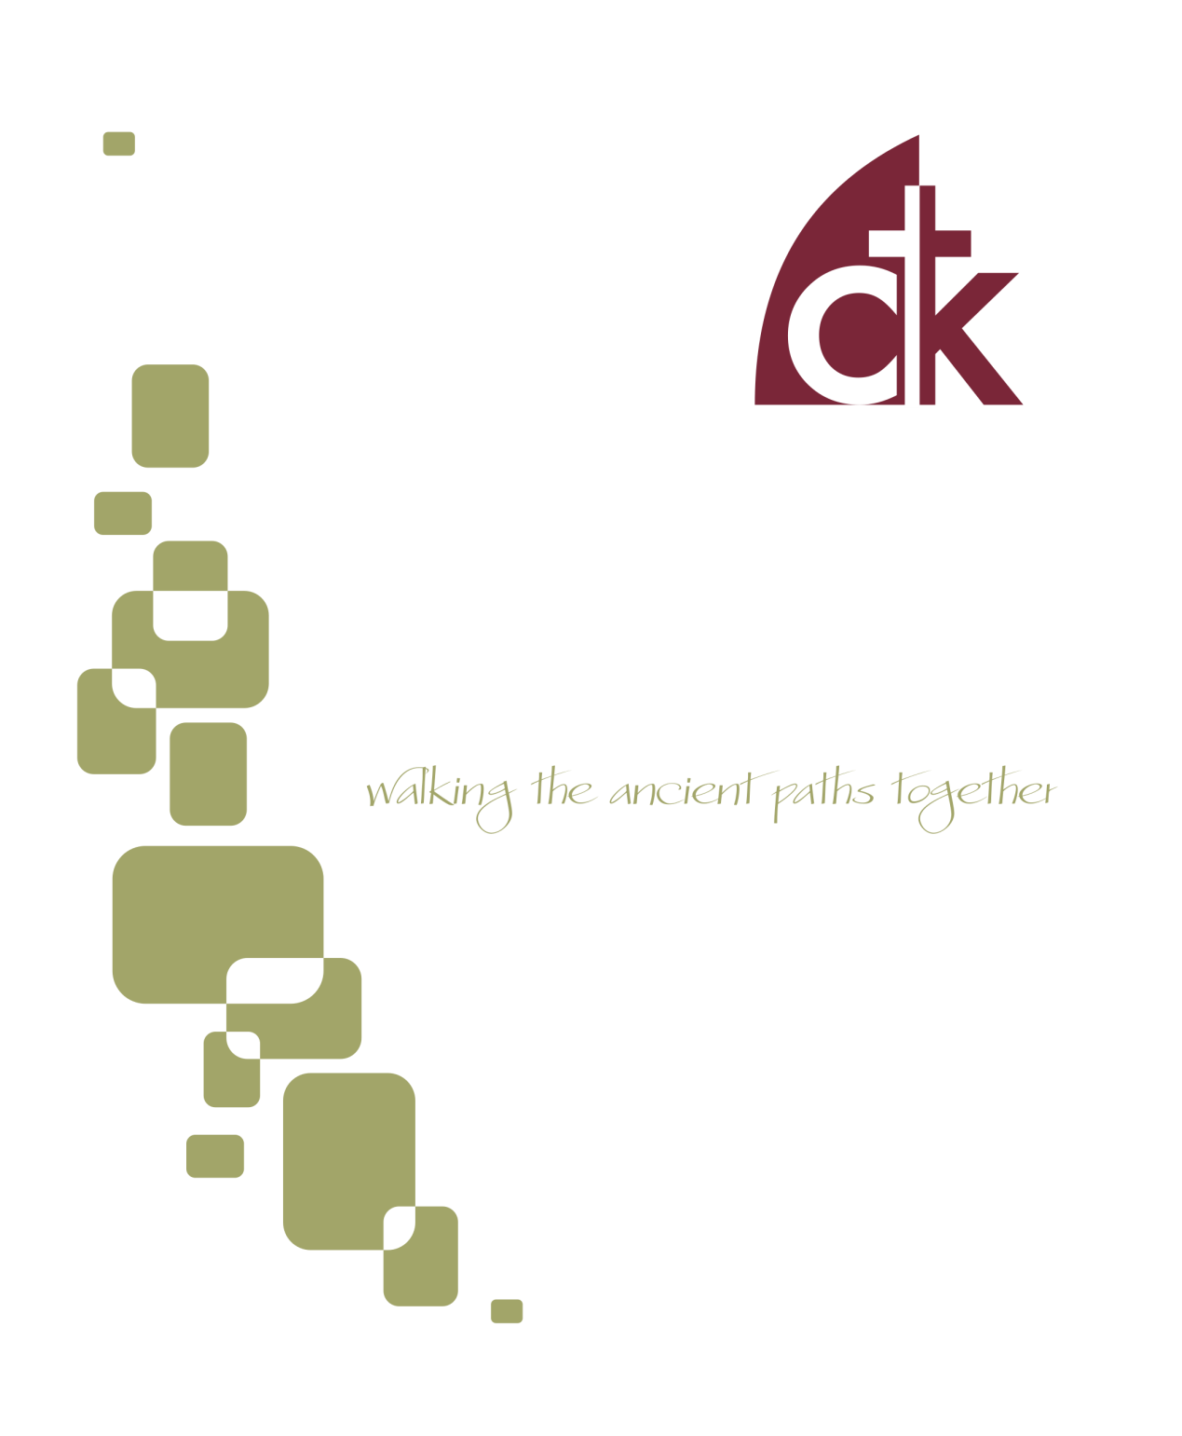
October 2016 Newsletter

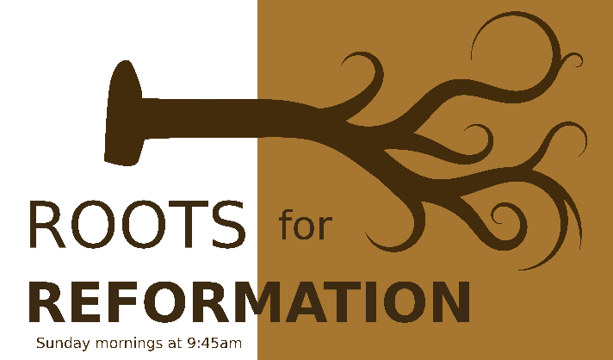
As the 500th Anniversary of the Protestant Reformation approaches, we have thematized our Sunday Schools around various Reformation-centered topics (currently, we are moving through the Westminster Confession of Faith). Such a study can raise some questions: Why study the Creeds? Why study Church History? Is that really a good use of our time? After all, one of the great watchwords of the reformation was sola scriptura, so shouldn’t our interest in Sunday School be more directly Biblical in its orientation?

Nothing but the Bible?
We certainly want to keep the Bible central in our life together as a church. The Bible alone is our final authority in all matters of faith and obedience. As the Westminster Confession puts it, “the whole counsel of God concerning all things necessary for His own glory, man’s salvation, faith, and life, is either expressly set down in Scripture, or by good and necessary consequence may be deduced from Scripture: unto which nothing at any time is to be added, whether by new revelations of the Spirit, of traditions of men.” So that settles it, right? Why study church tradition if the Bible alone is sufficient?
While it is true that the Scriptures are the final and ultimate rule for our faith and life, they are not the only source. The confession is sometimes misunderstood to be saying that the Bible is the only place to go to learn about God. Not only is that not what the confession is teaching, it’s also not what the Bible teaches! We learn about God through creation (Rom. 1:18-23), from our parents (Dtr. 6:7; Ps. 34:11), from pastors and teachers (Eph. 4:11), through the foolishness of preaching (1 Cor. 1:21), and from the traditions passed down through the church (2 Tim. 1:3-14). All of these sources of knowledge are derivative of God’s revelation, and all of them are subservient to Biblical authority (Acts 17:10), and therefore all of them are secondary, and yet God has been pleased to use each of them (and more besides) to teach us about himself.

“The whole counsel of God concerning all things necessary for His own glory, man’s salvation, faith, and life, is either expressly set down in Scripture, or by good and necessary consequence may be deduced from Scripture: unto which nothing at any time is to be added, whether by new revelations of the Spirit, of traditions of men” (WCF 1.6).
So the bulk of what we do should be directly focused on the Bible as the Word of God, and everything we do should derive from God’s revelation and conform to it, and yet there is a time and a place to think about the deposit entrusted to us through the faithfulness of our forefathers. It is good to consider the challenges they faced, the theology they taught, and the common faith they proclaimed.

What will I learn from studying the Reformation?
So we can study confessions and church history, but why should we study it? What can I expect to get out of such a study? Here’s an incomplete list:
- You can expect to deepen your understanding of the Bible. The men and women who came before us were committed students of the Scriptures. They didn’t always get it right, and that’s OK, but they left us a legacy of reflection for which we should be thankful.
- You can expect to better understand the current state of the church. That often happens when we study history. We don’t truly understand the present until we understand it as partially a product of the past. It’s the same with the church.
- You can expect to find examples to emulate. Our forerunners in the faith struggled with many of the same things we do. Our trials are not unprecedented; our questions are not new; our issues are not unique. How did faithful women and men endure in ages past? You won’t know unless you are a student of church history and theology.

So then you are no longer strangers and aliens, but you are fellow citizens with the saints and members of the household of God, built on the foundation of the apostles and prophets, Christ Jesus himself being the cornerstone, in whom the whole structure, being joined together, grows into a holy temple in the Lord (Ephesians 2:19-21)
- You can expect to better appreciate the continuity of God’s plan for his people. We didn’t arrive on the scene out of nowhere; on the contrary, we are heirs to a deep, wide, robust, and truly catholic tradition. God doesn’t form the church anew each generation; no, he builds it up, ever augmenting and perfecting the existing super-structure. We are bricks on top of previously laid bricks.
- You can expect to encounter foreign people and ideas. One of the best reasons to travel is to see things you’ve never seen before, to meet people who don’t speak and think and live like you do. It’s interesting to drop into an alien world, and it can transform the way you understand your own context. The same is true with studying our tradition. They don’t always ask the same questions that we ask. You are probably not genuinely curious as to how many angels can fit on the head of a needle, and your instinct is to regard such a discussion as silly. Fine, but why did the medieval scholastics ask it? Why didn’t they think it was silly? Figuring that out helps us appreciate their context and questions, and even if we still think it’s a bit strange, we nevertheless learn something about our own limitations and perspectives.
- You can expect to grow in faith. God has surrounded us with a great cloud of witnesses—some living, some dead, with Christ as the chief founder and perfecter of us all. As we learn from the variety of witnesses that God has put into our lives, we are better equipped to “run with endurance the race that is set before us” (Heb. 12:1).
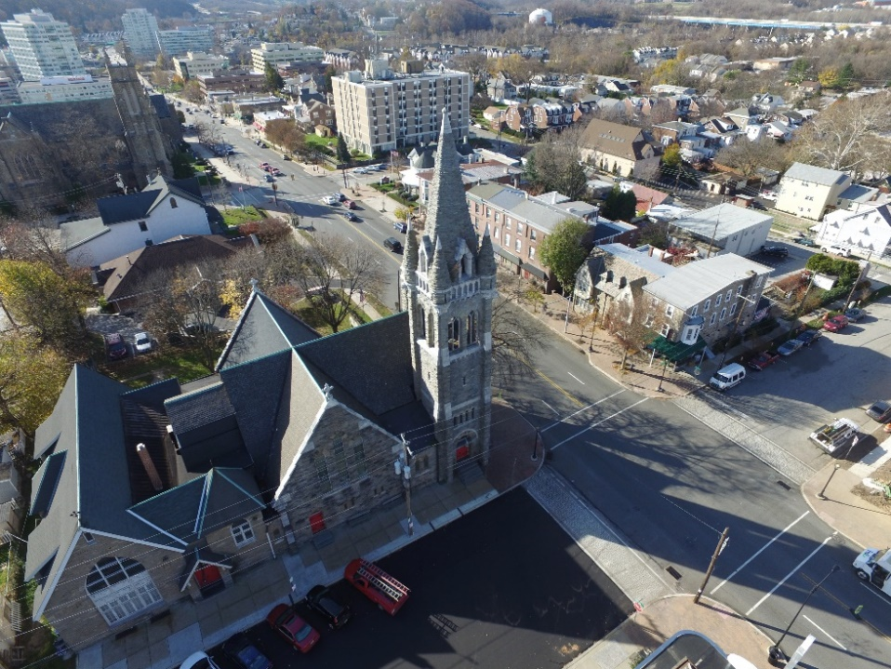
So join with us as we study our tradition together! As we do so, we stand on the shoulders of giants; or, perhaps better, we are built up as a temple of God, brick by brick, all grounded in the foundations laid by Christ and his apostles and prophets (Eph. 2:20).
Fellowship Dinner and Congregational Prayer
On October 5th there will be a fellowship dinner and congregational prayer meeting. The dinner begins at 5:30 pm and is provided by the church. The adults and youth aged middle school and above will meet from 6:30-7:30 pm for a report from the Kirkland Family about their ministry in Athens, Greece. On the 2nd and 4th Wednesdays, Home Bible Fellowships meet throughout the area.

Men’s Book Study
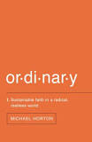
The men will be meeting on Saturday October 1st from 8:00 AM to 9:30 AM in the church office building at 117 E. 4th Ave. We are currently discussing the book "Ordinary" by Michael Horton. If you would like a copy of the book, or have other questions about this ministry, contact Rich DeLecce. (ddelecce@aol.com).

1st Sunday Potlucks
WIC will be hosting a potluck on the first Sunday of the month. Please join us October 2nd for this time of fellowship after the morning service. Please bring an entrée or a side dish to share. Avoid using nuts, nut products, or shellfish due to allergy concerns.

Saturday Women’s Bible Study
The Women’s Saturday Bible Study will commence their Bible Study on October15th at 9:30 am at the home of Maria Signorino. We will be studying ‘The Promised One, Seeing Jesus in Genesis’ by Nancy Guthrie. If you have any questions, please contact Charlotte Schmucker at 610- 647-1362.

Food Collection
Back to school time and the food pantry could use its regular nonperishable items and any items for packing lunches, too! Please give generously to the CNC. If you have any questions, please feel free to contact either Lauren Elban or Michele Eichert. The next collection is October 16th!

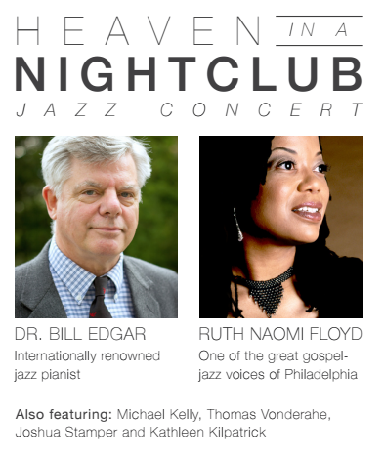
On October 21st at 7PM the Community Life Committee will be hosting the next event in our CTK Arts Series. This event will be a jazz concert entitled, Heaven in a Nightclub. The music and program will be performed by six musicians and will feature Dr. Bill Edgar, who is widely known as Professor of Apologetics at Westminster Theological Seminary, and Ruth Naomi Floyd, who is one of the great gospel jazz voices of the Philadelphia area.
The entry price is $12 for adults and $7 for students and will include wine, cheese, and other refreshments. All CTK members and attendees are strongly encouraged to join us and to bring friends. It is the hope and desire of the Community Life Committee that this will be a time of great fellowship and outreach for our church family.

If you are interested in helping out with the event please contact one of the committee members listed below:
Mike LoRusso , John Erickson, Dana McGahey, Nicolas Kirkland, Jack and Stephanie Newman

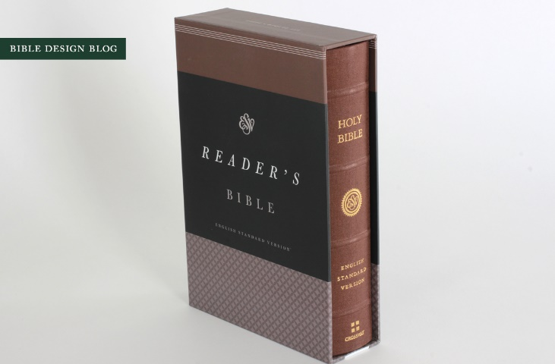
We recently received several new covenant children as communing members of our church (congratulations!), and when we did so, the church gave them an ESV Reader’s Bible. It’s a different sort of Bible. No annotations. No headings. No notes. No references. No columns. And.. wait for it… no verse numbers either. Why would anyone want such a Bible?
Here’s one reason: it will forever change the way you read God’s word.

Most Bibles are formatted for searching and study, not for reading
Most Bibles that you’ll pick up at the store are formatted in such a way to make it easy to find the place you need to be. They are packed full of verse numbers, cross-references, topical headings to inform you what the section you’re reading is “about,” and a handful of footnotes to help address translation or textual issues. Many also include a concordance, book introductions, study notes, maps, diagrams, and more. The more stuff the better right?
Picture from bibledesignblog.com, which is a wonderful resource for finding the right Bible for you.
Well, it depends on what you’re looking for. If you’re trying to find an elusive verse, or trying to keep up with the discussion in a group Bible study, or following the logic of a sermon that is jumping from passage to passage, you probably want verse numbers and cross-references. If you want to dive more deeply into a sentence of phrase, or get answers to questions about this or that verse or book, then you’ll want the notes and helpful diagrams a study Bible provides.
But if you want to read—just read—then you are looking for immersion. All of these extra things ruin immersion. They’re like someone blowing gum behind you at the movies, or a phone beeping at you while your deep in a good book, or a parade of motorcycles blaring their way down Fayette on a peaceful Sunday morning. They’re distractions.

A Reader’s Bible encourages you to read the way writers write
All of those extras are helpful, don’t get me wrong, but they encourage you (often without you even noticing it) to read the Bible in tiny chunks. They force you to read verse by verse or even phrase by phrase.
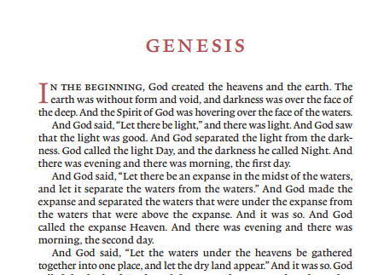
That’s not how you read other books. That’s not how you read the latest mystery thriller, or classic fiction, or poetry, or a biopic, or a theological treatise, or a blog post. When was the last time you read something with numbered lines?
You don’t read other books verse-by-verse or line-by-line. You read them thought-by-thought. Why? Because that’s how writers write. Writer’s don’t (usually) expect you to pick apart their sentences and break them up into little bits. They pick their words carefully, of course, and they structure their work thoughtfully, but they do so in order to encourage their readers to keep reading. They don’t want their readers to stop and puzzle over this or that phrase. They want you to be surprised, sure, but not so surprised that you stop, so a good writer will write in such a way that you are constantly learning something new, but also constantly moving forward.
An excerpt from the ESV Reader’s Bible.
Reference and Study Bibles are wonderful, don’t get me wrong. They are a useful resource for study, to be sure, but they are not as useful for processing the Scriptures as their original authors meant them to be read and appropriated. Different tools are useful for different tasks. A knife is great for cutting vegetables, but it makes a terrible (and dangerous) pastry scraper, despite the fact that both might have similar shapes and made of similar materials.
The ESV Reader’s Bible is a great tool for reading. It’s formatted, beginning to end, to look like a “normal” book. Of course it’s not a normal book—it’s the word of God—and yet it’s precisely for that reason that we should be all the more desirous to strive for immersive reading.
We have a couple of copies available at the book table. Check them out!

Dearest friends,
Here are some further news and requests. Thank you so much for your prayers!

1) Pray for the kids as the oldest is starting a new school and needs to put forth a full effort
2) Pray for their car situation – they need to decide if they should replace their car.
3) Pray for their church as they are I need of a Pastor.
4) Pray for upcoming travel for Flavien to a few Muslim countries.
5) Pray for Flavien’s work on his transcripts for a new book.
6) Praise for the decline in the Pound and Euro, this has been a great benefit to their finances.

So please pray for us. That our gaze would be fixed on Christ. That we would trust Him in circumstances that we do not understand. That our loving Father would accomplish His purposes in us and through us in all this. That our children would grow in faith, trust and holiness. Thank you very, very much in advance,

The Pardigons

We are grateful to Christ the King, for your participation with us in prayer and generous support. Thank you! Pray with us for these things:

The atmosphere of fear, uncertainty, suspicion that hangs over the whole region.
Pray that our God would use this for great purposes.
Pray that believers would learn more of trusting God and find the opportunities to shine the light in word and deed.
Pray for newly baptized believers to persevere in their faith (2 baptized this summer).
Pray for our internship program starting on 17 October – for our 2 pilot students and for teachers and mentors.

John

 | Oct 2 | Oct 9 |  | Oct 16 |  | Oct 23 | Oct 30
Greeters  4th Ave | Anna Ludlum | Nicole Davis |  | Elizabeth Stahl |  | Rich/Debbie DeLecce | Daniel Stahl
Greeters Fayette Street | Debbie Doyle | Ray Doreian |  | Kathy Daly |  | Charlotte Schmucker | Sharon Tobin
Set Up | Jay Signorino  Nic Kirkland | Dave Hudson  Dan Hoffman |  | John Erickson  Ian Buchanan |  | Jerry Davis  Pat Canale | Jay Signorino  Nic Kirkland
Ushers | Jay Signorino  Mark Hoffman  Dave Ritter  Josh Tyson | Jerry Davis  Pat Canale  Dan McGahey  Peter Stahl |  | Dave Hudson  Chip Signorino  Rob Ghrist  Tom Blackburn |  | Dave Ritter  Jack Newman  Dave Hudson  John Erikson | Jay Signorino  Mark Hoffman  Dave Ritter  Josh Tyson
Sunday School Nursery | Liz Hudson |  | Maria Signorino |  | Anne Schneider | Nicole Canale | Clarice  Helfand
Morning Nursery | JoshTyson  Lucy Tyson Renee Blackburn  Josh Blackburn | Michelle Eichert Anna Ludlum McKenna Canale  Daniel Stahl |  | ChipSignorino Maria Signorino  Erin Buchanan Ian Buchanan |  | Liz Hudson  Charlotte Schmucker  Pat Canale Luca Canale | Anne Schneider Joel Schneider Christine Hoffman  Richard Stahl
Evening Nursery | Jay Signorino  Carmen Signorino | Terry Smith  Lauren Huber |  | Mark Elban  Lauren Elban |  | Josh Helfand  Christy Helfand | Peter Stahl Elizabeth Stahl

