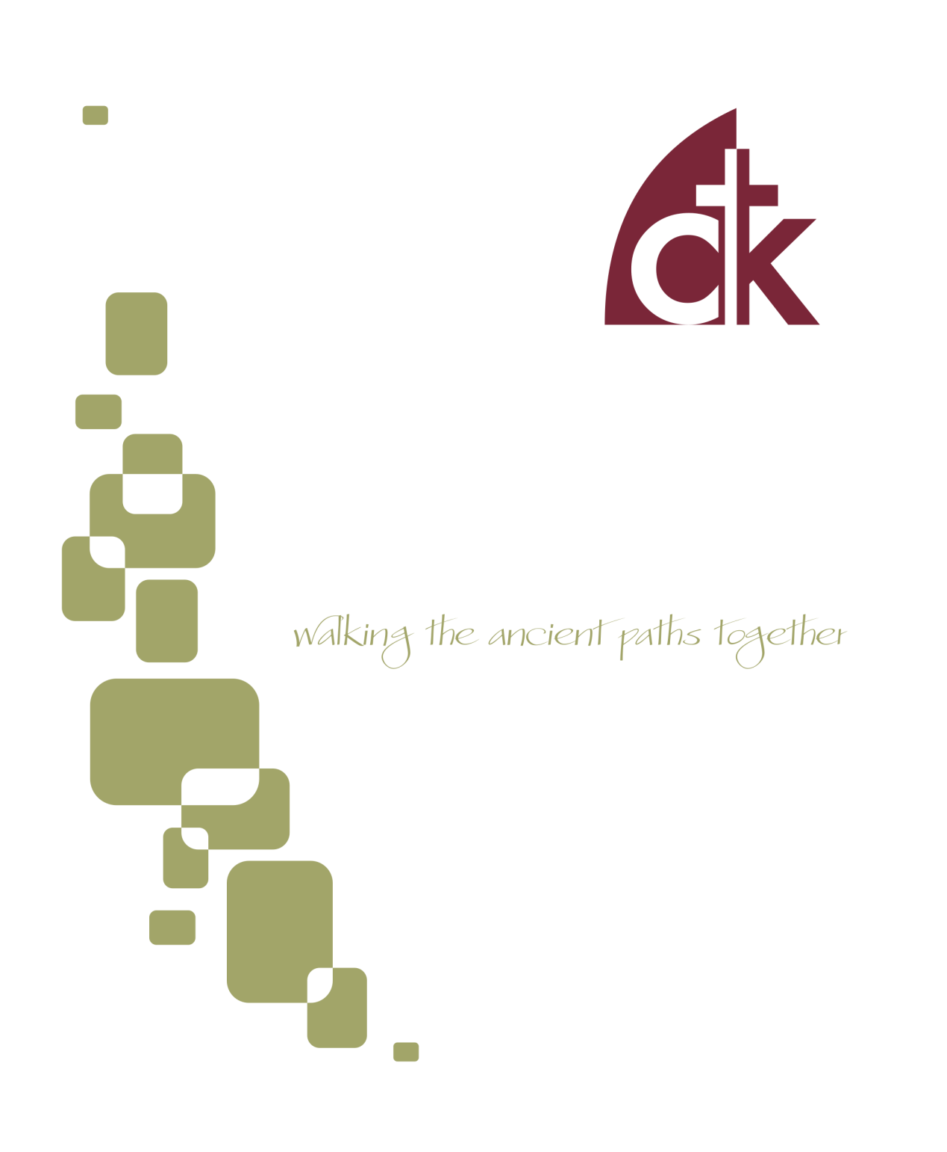
September 2016 Newsletter

One of the great pleasures of fall is the joy we find in looking at the beauty of our Father’s world. Our eyes have been created with the capacity to soak-in beauty and delight in it. As flowers lose their summertime luster, our “looking” turns to nature’s fading beauty as Pushkin called it. Are you a looker? Are you looking? What are you looking at? Why are you looking? Should you be looking?
The Bible has much to say, positively and negatively, about our eyes and looking. We can “look” in a way that is honoring to God and a blessing for us. Conversely, we can misuse the gift of sight in as many ways as we can imagine.
Let’s consider how we might look well as we look ahead to the fall.

Look to Jesus
This is the great call from Hebrews 12. It was the special privilege of the people living in Palestine 2000 years ago to look on Jesus, the incarnate Son of God. Simeon, who had been waiting and watching for the consolation of Israel, was able to take him in his arms and declare, “…my eyes have seen your salvation…” We have the blessing of looking on and to Jesus through the eyes of faith. While we long for the day when we will be with him and see him face-to-face, we dare not doubt in the meantime the veracity of the promise of Jesus, “Blessed are those who have not seen and yet believed.”

THEREFORE, SINCE WE ARE SURROUNDED BY SO GREAT A CLOUD OF WITNESSES… LET US RUN WITH ENDURANCE THE RACE THAT IS SET BEFORE US, LOOKING TO JESUS, THE FOUNDER AND PERFECTER OF OUR FAITH. HEBREWS 12:1-2
Do we believe this? Do we believe that the look of faith is particularly blessed for our spiritual well-being in this world or do we view it as a kind of consolation prize for the runners-up?
We are returning this fall to the Book of Acts in our morning sermons. In Acts 1 we read that the disciples were mildly rebuked for continuing to look up into heaven after the ascension. Having been accustomed to looking at Jesus with their physical eyes, they would need to adjust their vision. The focus and object of their attention would remain the same – Jesus. The looking would take place through hearing the Word and faith.
Looking to Jesus is not a passive process or a consolation prize for us. It is our life, our joy, our food. We do this as we devotionally and consciously remember Jesus and his ministry. It is different than prayer and it is different than Bible reading unless you happen to be in the Gospels. It is the deliberate practice of meditating on his life, suffering, exaltation and current reign and intercession for us.

Look to the Interests of Others
Remarkably and yet somehow not surprisingly, when we look on Jesus we see other things. Jesus saw people. In particular he saw the needs of the people around him. First and foremost, he saw their need for forgiveness. Additionally, he saw their pain. Paradoxically, as we look at Jesus, the horizon expands.
It is natural for us to look after ourselves. Paul calls this looking to our own interests and then challenges us to take a step farther. As a people whose eyes are fixed on Jesus, we are urged, like Jesus, to look to the interests of others. If you’ll pardon the pun, we are not called to be merely on-lookers. Instead we are called to be those who see and in seeing are moved to concern and action. While we can’t address all of the misery we see, we can serve somewhere and in some way. The starting point for that service is having eyes that see well. They are eyes that hold a prayer as they see - Lord, show me how to help. They are eyes that in the simple things of life imitate Jesus who when he saw a brother in need, loved in word, deed and truth.

LET EACH OF YOU LOOK NOT ONLY TO HIS OWN INTERESTS, BUT ALSO TO THE INTERESTS OF OTHERS. PHILIPPIANS 2:4

Look to the Harvest
When he saw the crowds, he had compassion for them, because they were harassed and helpless, like sheep without a shepherd. Then he said to them, ‘The harvest is plentiful but the laborers are few; therefore pray…’ Matt 9:36-38
Look, I tell you, lift up your eyes, and see that the fields are white for harvest. John 4:35
In 2016 we have spent time looking to the welfare of our souls through the Psalms. We must always be engaged in that essential nurture of our own soul in Jesus. Yet from the very beginning of that series in Psalm 51 we have acknowledged that the care of our souls is never disconnected from concern for the Kingdom. David longed for a renewed soul not only for himself, but for others (Ps 51:13). As we return to Acts this fall, we will be renewed as we walk with the early church into the fields white for harvest.
May this fall be a time for us to gaze upon the beauty of Jesus. May this fall be for us a time when we see the crowds and look upon the whitened fields with the eyes of our Jesus. May it be for us a season when our looking translates to compassion; when our compassion translates into words of truth and deeds. May it be that the Lord of the harvest would be pleased to send us and bear fruit through us for his glorious Kingdom.
Look well!
- Eric

Labor Day Picnic
The Erickson family has graciously invited everyone to their house for a Labor Day picnic on Monday, September 5th from 11-4pm (lunch will be at noon). Come when you can, leave when you must for lunch and lawn games. The Erickon's will provide meat for grilling. Please use this http://www.signupgenius.com/go/508094aaeaf2ca13-labor for side dishes. Please RSVP to carole.erickson@verizon.net with the number attending. We are looking forward to hosting as many as can come. Parking will be explained when you arrive. 571 Gulph Road Wayne 19087
Fellowship Dinner and Congregational Prayer
On September 7th there will be a fellowship dinner and congregational prayer meeting. The dinner begins at 5:30 pm and is provided by the church. The adults meet for prayer from 6:30-7:30 pm and youth aged middle school and above will meet upstairs for a time of singing, prayer, and teaching. On the 2nd and 4th Wednesdays, Home Bible Fellowships meet throughout the area.

Men’s Book Study
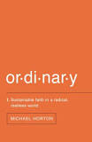
The men will be meeting on Saturday September 10th from 8:00 AM to 9:30 AM in the church office building at 117 E. 4th Ave. We are currently discussing the book "Ordinary" by Michael Horton. If you would like a copy of the book, or have other questions about this ministry, contact Rich DeLecce. (ddelecce@aol.com).

Youth Group River Party
Join us Saturday September 10th for a party on the river! The Kirklands and Jay and Carmen Signorino will be hosting us for a time of food, fellowship, and river-related fun and games. The festivities will begin at 11:00 am and continue until 4:00. We will start with a cookout, so bring an appetite, sunscreen, a swimsuit, cheap sunglasses, towels and any games or activities you'd like to share. All Middle School and High School students and their families are welcome to join in the fun. Parents or appointed guardians are responsible for the safety of their children, and we could also use a couple of Dad volunteers to keep an eye on river activities. RSVP to Tommy Keene (tommyk@christthekingpca.org).

1st Sunday Potlucks
WIC will be hosting a potluck on the first Sunday of the month. Please join us September 11th for this time of fellowship after the morning service. Please bring an entrée or a side dish to share. Avoid using nuts, nut products, or shellfish due to allergy concerns.

Saturday Women’s Bible Study
The Women’s Saturday Bible Study will commence their Bible Study on September 17th at 9:30 am at the home of Maria Signorino. We will be studying ‘The Promised One, Seeing Jesus in Genesis’ by Nancy Guthrie. If you have any questions, please contact Charlotte Schmucker at 610- 647-1362.

Food Collection
Back to school time and the food pantry could use its regular nonperishable items and any items for packing lunches, too! Please give generously to the CNC. If you have any questions, please feel free to contact either Lauren Elban or Michele Eichert. The next collection is September 18th!

Spring Mill Ministry
One Sunday each month, members of Christ the King meet with residents of Spring Mill retirement community for fellowship, hymn singing, and studying God’s word. Our friends in this community enjoy this time, especially since they are not able to get out and attend church at this stage of life. It also provides a way care for widows. Please contact Peter Stahl if you are interested in joining one Sunday and/or join us on May 22nd.

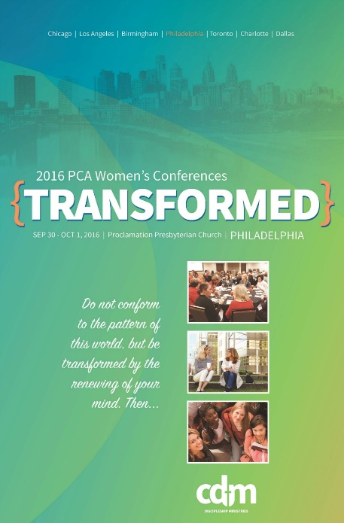
Ladies and teen girls, this fall, in lieu of our own CTK Women’s Retreat, we will be joining other PCA women in the northeast region for the “Transformed” conference to be held at Proclamation Presbyterian Church, September 30-October 1.

We invite all women (Ages 14, 40, or 104!) to join us as we seek to be TRANSFORMED through studying Romans 11:33-12:2 together. The keynote speaker for the northeast region is Melissa Kruger. Melissa Kruger serves on staff as Women’s Ministry Coordinator at Uptown Church (PCA) in Charlotte, North Carolina and is the author of The Envy of Eve: Finding Contentment in a Covetous World and Walking with God in the Season of Motherhood. In addition to keynote talks, breakout workshops will also be presented.

Schedule: Friday, September 30, 7 pm to 9 pm

Saturday, October 1, 9 am to 2 pm (includes lunch and 2 workshops)

Workshop Choices:

Flourishing: How the Gospel Changes Everything – Steph Hubach

How to Think Biblically about My Body – Ellen Dykas

How Do I Get Enough? – Callie Miller

Living with Purpose on Purpose in the Afternoon of Life – Sharon Betters

Talking to Kids about Tough Topics – Julie Lowe

More information is available at http://www.pcacdm.org/transformed2016/transformed-philadelphia

Stay tuned for registration information at a reduced price.

Have you checked the Website Lately?
Have you been to the website lately? There’s lots of new stuff to see! Not only is it more streamlined and up-to-date, we’ve been rolling out new editions left and right. We’ve started posting the newsletters online, and we’ve also started a new series called “Preparing for Worship” on the blog. Preparing for Sunday actually makes our worship fuller and more engaging, and the series of blog posts is designed to do just that by informing your family what hymns we will be singing, what texts we will be studying, and also asking some preparatory questions to steer our minds and hearts in the right direction.
And more additions are forthcoming, so keep an eye on it and let me know what you think (tommyk@christthekingpca.org).

Now is the Time to Gather Operation Christmas Child Supplies
We will be continuing our tradition of a shoebox packing party this year in November. November seems like a long way off, but actually right now is a great time to start collecting things for the shoeboxes! There are tons of Back-to-School items on sale right now, and Samaritan’s Purse heartily recommends those kinds of items as gifts. For more information visit their website. Here are a few of their suggestions:
- School Supplies: pens, pencils and sharpeners, crayons, markers, notebooks, paper, solar calculators, coloring and picture books, etc.
- Non-liquid Hygiene Items: toothbrushes, bar soap, combs, washcloths, etc.
- Accessories: T-shirts, socks, hats, sunglasses, hair clips, jewelry, watches, flashlights (with extra batteries), etc.
- Crafts: Make your own items such as hair bows, finger puppets, and friendship bracelets.

Why Sunday School?
If you’ve been with us over the summer, you know we have been moving through a series we have called Why Church? But there’s a related question: why Sunday School? After all, there’s no command in Scripture that a church has to do Sunday School. So what’s its function? Why do we do it?
The gospel hits every part of us. It changes our hearts and affections. It changes our will and desires. It sets us free. It causes us to grow and mature in faith. It also affects how we think. In fact, the mind is a centrally important component in Christian growth and maturity. Here’s how Paul puts it: “do not be conformed to this world, but be transformed by the renewal of your mind, that by testing you may discern what is the will of God, what is good and acceptable and perfect” (Romans 12:2 ESV). That’s strong language! Think about that for a minute. Paul wants us to be transformed, and he sees that transformation as mediated by our minds. How we think. What we know. How we understand the world, the God who made it, and my relationship to Him. Your mind matters.
One commentator on this passage argues that Paul’s belief about the development of our minds—about Christians seeking to grow in knowledge and understanding—is remarkable for his time. The Romans didn’t believe that. They believed that intellectual pursuits were only for certain kinds of people. Not everyone needs to cultivate their minds—carpenters and fishermen don’t need to be intellectual or philosophical. And yet Paul calls all of us, in the variety of gifts and skills that God has given us, to cultivate our minds as a component of Christian growth. That’s not the only component of Christian growth—Paul elsewhere tells us to train our wills and our bodies as well (1 Cor. 9:24-27)—but it is a necessary component.

Teach Your Children Well
That’s our goal in Sunday School. We aim at the will and the heart as well, but Sunday School provides for us some unique opportunities to explore our common faith. We want to change our minds, and Sunday School helps us to do that by putting us into intentional dialog with one another as we seek together to better understand God’s Word.

Sunday School Launch Date: Sunday September 11
So join us Sunday September 11th for a new season of Sunday School. Your teachers have been working hard to get ready and are excited for the coming semester! We have Sunday School classes for children 2 and up, all the way through adult. When and where? 9:45 am on Sunday mornings. The class locations are as follows:
- Nursery: Church building, in the nursery room
- 2 ½ - 3 Year Olds: Church building, in the nursery room, with Kate Simons
- 4 and 5 Year Olds and Kindergarten: Church office, with Debbie DeLecce and Dottie Doreian
- 1st and 2nd Grade: Church office, with Dana McGahey and Carmen Signorino
- 3rd, 4th, and 5th Grade: Church office, with Debbie Ghrist and Terry Smith
- Middle School: Church building, upper room, with Rex Anderson and Mark and Lauren Elban.
- High School: Church building, upper room, with Jack Newman and Tommy and Sarah Keene.
- Adults: Church building, middle room, with Eric Huber

The Promise
Sometimes getting up in the morning, dragging everyone into the car, and sitting through Sunday School can seem like more effort than its worth. Let me remind you of the payoff. Paul says that through the renewal of our minds we are able to “discern the will of God.” That’s an amazing statement. Through study, through iron-sharpening-iron conversations, through good questions and loving responses, we are able to “have the mind of Christ Jesus” (1 Cor. 2:16). Wisdom from above! I look forward in the coming months to learning together.

- Tommy

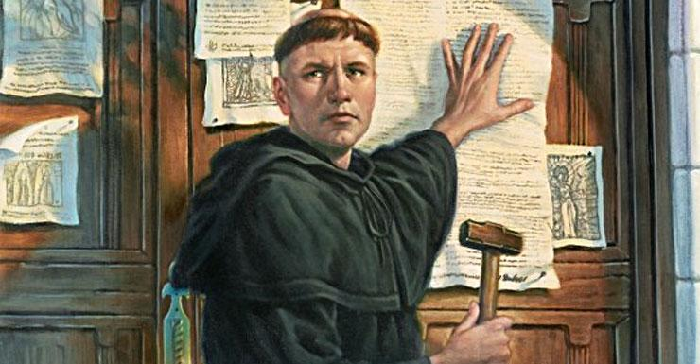
On October 31, 1517, a young monk posted his “95 Theses” on the door of the Wittenberg Castle church. It attacked the Catholic practice at the time of selling indulgences for forgiveness of sins, asserting that the church must be guided by Scripture alone, and that salvation was through a person’s faith, rather than their works.
Luther’s act would set in motion a series of events that would lead many people to gradually coalesce into a new movement: The Protestant Reformation.
As Reformed Presbyterians, we are direct descendants and heirs of these faithful giants. With the rest of Christendom, we of course trace our tradition back through the Middle Ages and into the Apostolic tradition, founded as we are on the teachings of Christ, Israel’s Messiah and ours, and his apostles (2 Peter 3:2; Eph. 2:20). Yet it is the Protestant Reformation that gave voice and clarity to the distinctives of our church: sola scriptura, sola fide, sola gratia, solus Christus, soli Deo gloria. Scripture alone, faith alone, grace alone, Christ alone, and to God alone be glory.
In 2017 we arrive at the 500th anniversary of that pivotal day.

Roots for Reformation: Adult Sunday School
The reformation is not over. One of the watchwords of the Reformation was the call to be “always Reforming.” The phrase is easily misunderstood. It’s not a call to be constantly changing and shifting with the times; quite the contrary: it is a call to be continually engaged in conforming our lives together to the teachings of Christ as delivered to us in His Word. As such, it involves a kind of dual vision: (1) holding fast to our traditions and continually refining them in light of the Scriptures (2 Thess. 2:15; 2 Tim. 1:3-14); and (2) moving forward in our own time and context through persevering faithfulness.

BY THE HOLY SPIRIT WHO DWELLS WITHIN US, GUARD THE GOOD DEPOSIT ENTRUSTED TO YOU. (2 TIMOTHY 1:14)
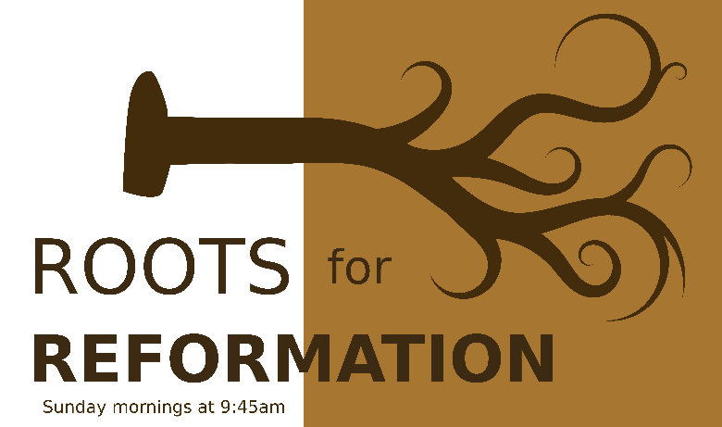
Last semester we began a new Sunday School series that will take us through the end of 2017. We are calling the series “Roots for Reformation,” which is an attempt to capture this dual vision: looking back to our roots in order to continue to persevere in our present environment. Our intent is to honor and learn from our forebears, to understand their context and teaching, to honor the teachers and teachings and texts that they themselves honored, and in doing all that to move forward in our own lives of faith. Over the course of the next two years we hope to consider a number of Reformation-themed topics:
  - Galatians, Spring 2016. This book provided Luther and others with the key theological foundation for sola fide.
  - The Westminster Confession of Faith, Fall 2016. This confession, completed in 1646 in England, is a masterful description of theological standards of the Reformation. Our denomination uses these documents as our “subordinate standard” as well—though Scripture is our ultimate standard, this document expresses what most Reformed Presbyterians believe the Bible teaches.
  - A Survey of Church History, 2017. We are pleased to have Dr. Jonathan Yonan, Associate Professor of Church History and Dean of the Templeton Honors College, to walk us through the seminal events throughout the history of the church.
Join us as we learn together, discuss the big questions, and grow in our understanding of the traditions passed down to us.

- Tommy

 | Sept 4 | Sept 11 |  | Sept 18 |  | Sept 25
Greeters  4th Ave | Anna Ludlum | Nicole Davis |  | Elizabeth Stahl |  | Rich/Debbie DeLecce
Greeters Fayette Street | Debbie Doyle | Ray Doreian |  | Kathy Daly |  | Charlotte Schmucker
Set Up | John Erickson  Tom Blackburn | Jay Signorino  Nic Kirkland |  | Dave Hudson  Dan Hoffman |  | Jerry Davis  Pat Canale
Ushers | Jay Signorino  Mark Hoffman  Dave Ritter  Josh Tyson | Jerry Davis  Pat Canale  Dan McGahey  Peter Stahl |  | Dave Hudson  Chip Signorino  Rob Ghrist  Tom Blackburn |  | Dave Ritter  Jack Newman  Dave Hudson  John Erikson
Sunday School Nursery | Maria Signorino |  | Nicole Canale |  | Liz Hudson | Clarice  Helfand
Morning Nursery | Anne Schnieder Joel Schnieder  Dana McGahey Abbie McGahey | Josh Helfand Christy Helfand Debbie Ghrist Annie Ghrist |  | Charlottle Schmucker Maria Signorino Chip Signorino Abby Schnieder |  | Michele Eichert Christine Hoffman  Pat Canale Luca Canale
Evening Nursery | No Evening Service | Peter Stahl Elizabeth Stahl |  | Mark Elban  Lauren Elban |  | Terry Smith  Lauren Huber

